Exercises: Deployment to Cloud
Exercises for the "Containers and Clouds" course @ SoftUni

Create WordPress Site Using Azure Portal
Our task now is to create a WordPress site in Azure. WordPress can be run on a few different Azure services: AKS, Virtual Machines, and App Service. Let's deploy out first WordPress site to Azure App Service with Azure Database for MySQL – Flexible Server.

Step 1: Create the Site
Go to Azure Portal on https://portal.azure.com and log in. Then, in the search box, type "WordPress" and select [WordPress] from the Marketplace:
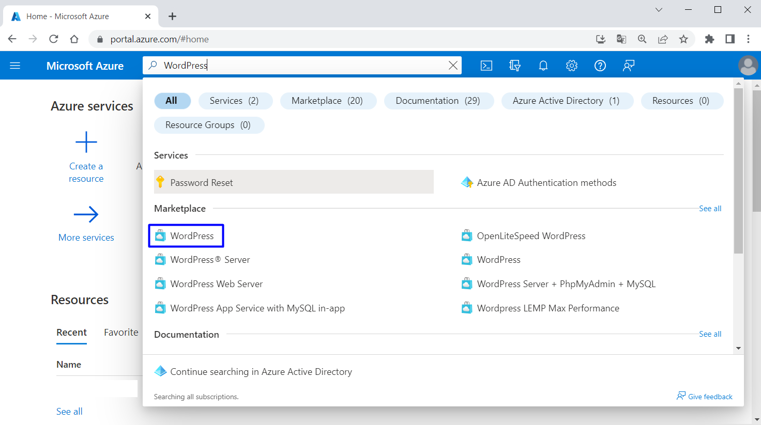
You should be on the "Create WordPress on App Service" page. For your convenience, you can follow this link: https://portal.azure.com/#create/WordPress.WordPress
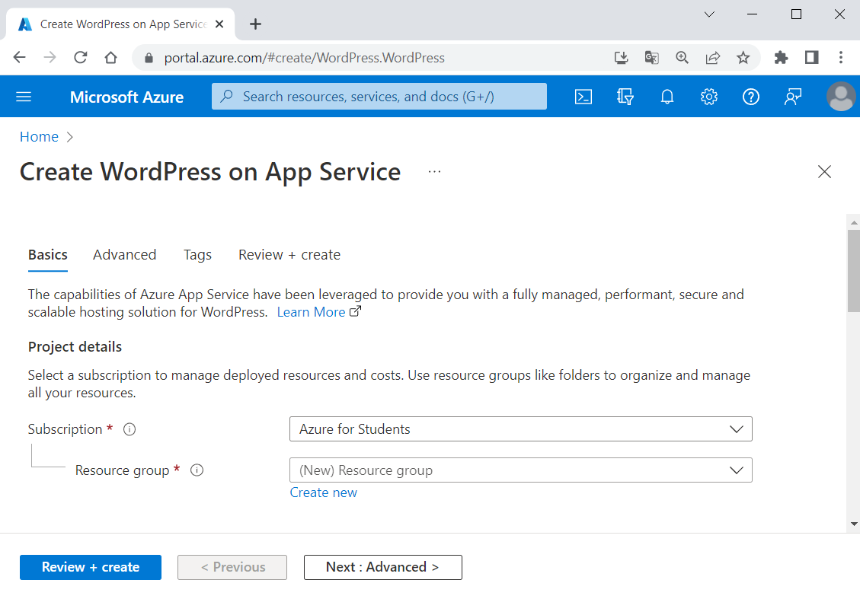
In the "Basics" tab, under "Project details", make sure the correct subscription is selected – "Azure for Students":
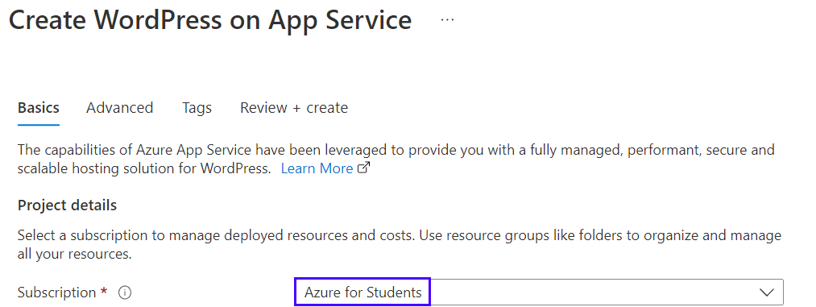
Тhen choose to [Create new resource group]. Type "WordPressResourceGroup" for the name:
Select a region near you that you want to serve your app from:
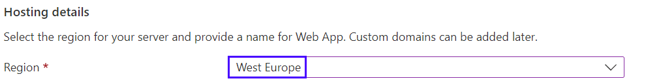
Provide a name for the Web App, which should be unique. You can name it "wordpressapp{your name}":
Select [Basic] for hosting plan:
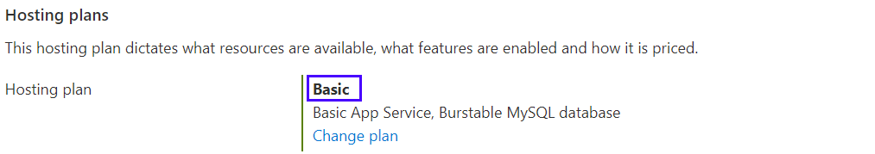
Under "WordPress Settings", type an admin email, admin username, admin password and admin confirm password. The admin email here is used for WordPress administrative sign-in only:
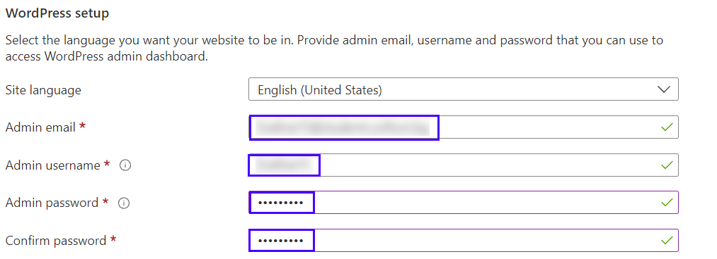
Remember your credentials for later. Then click on [Review + create]:
Click on [Create] to create the resources:
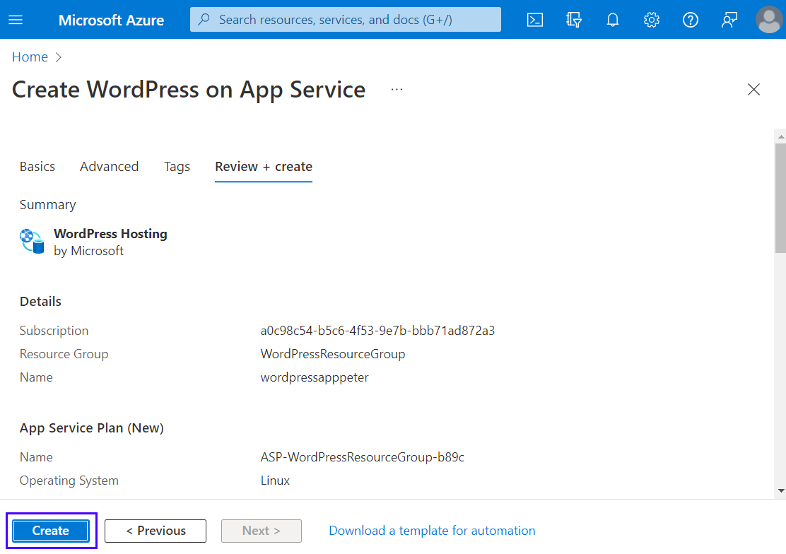
Then wait for the deployment to finish and click on the [Go to resource] button:
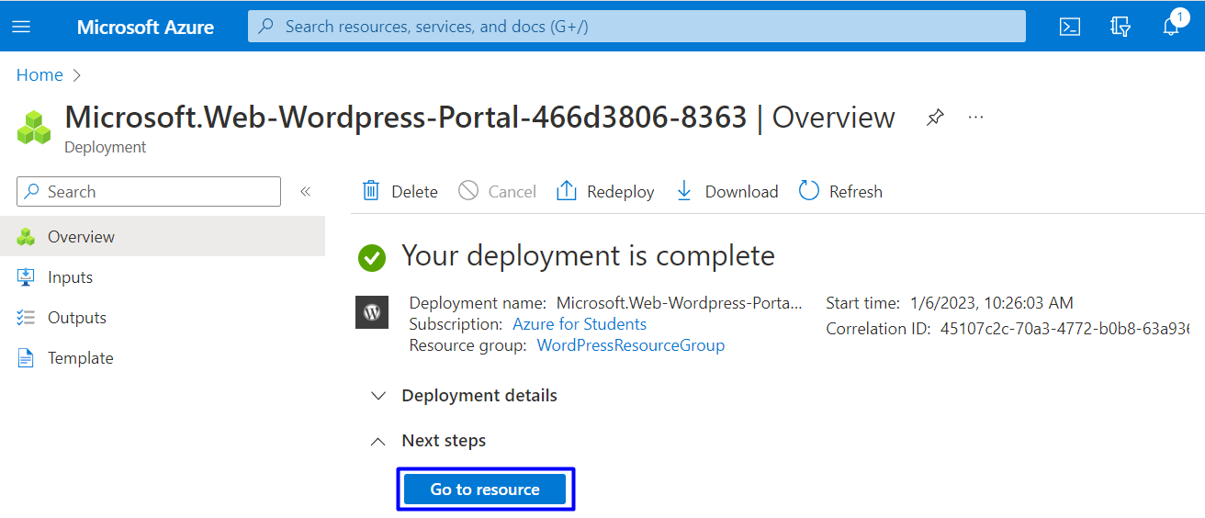

Step 2: Browse Site
You can click on the URL of the site in the "App Service" page, in the [Overview] tab to access the site:
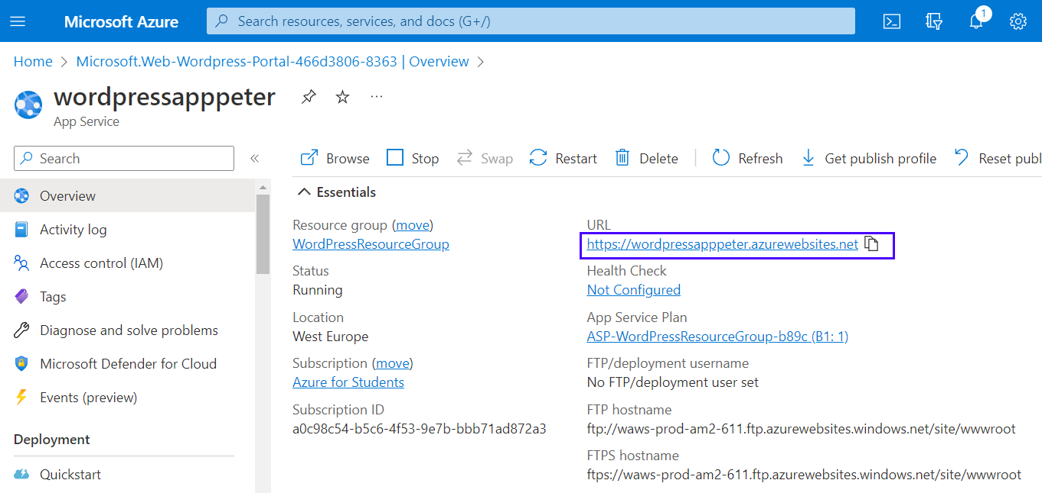
Or you can also navigate directly to https://<app-name>.azurewebsites.net.
Your site needs time to install. Wait for it:
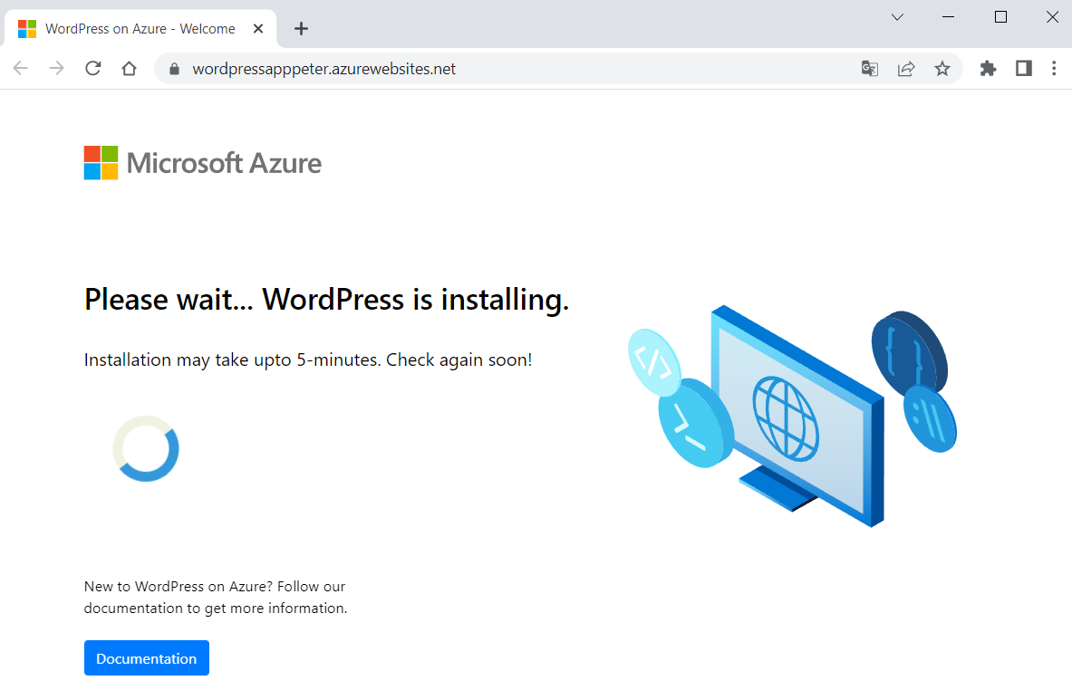
When ready, verify the app is running properly. If you receive an error, allow a few more minutes for the site to load and then refresh the browser.
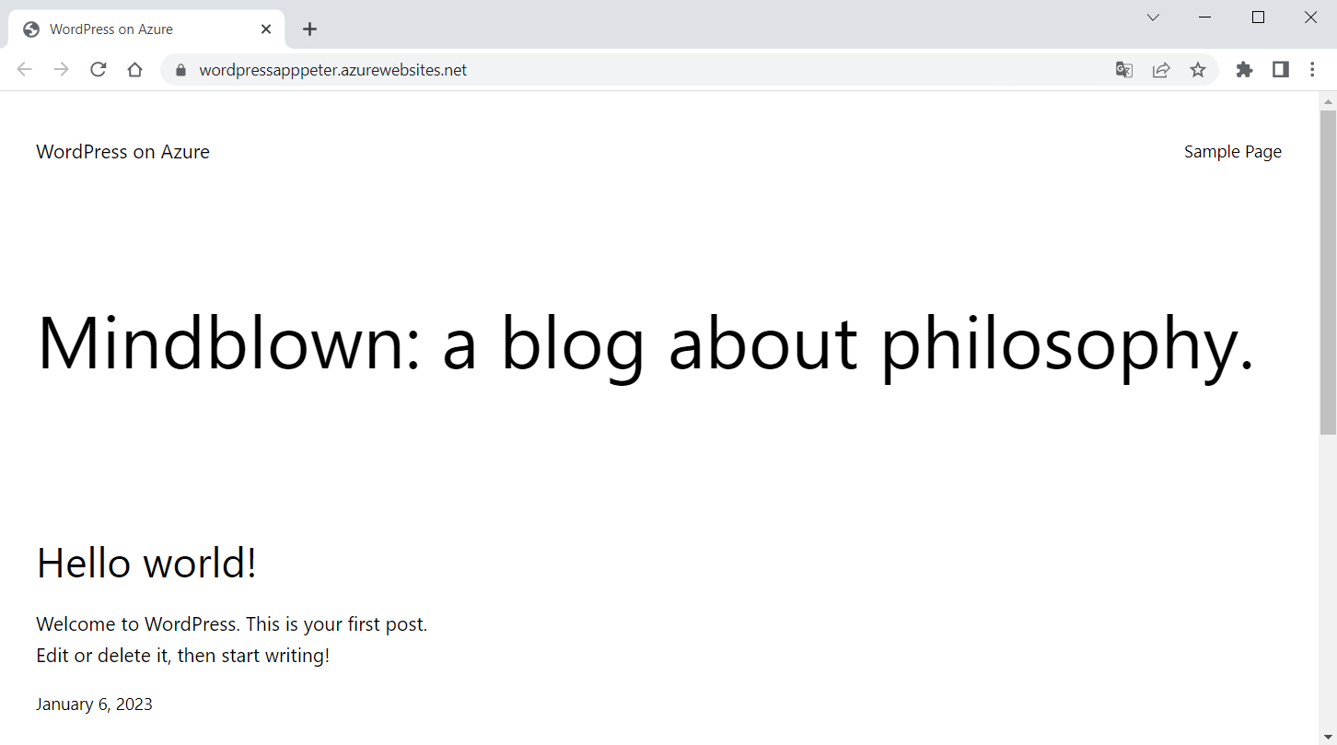
To access the WordPress Admin page, browse to /wp-admin and use the credentials you created in the "WordPress Settings" step:
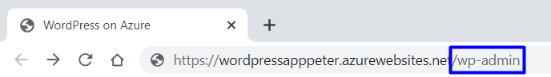
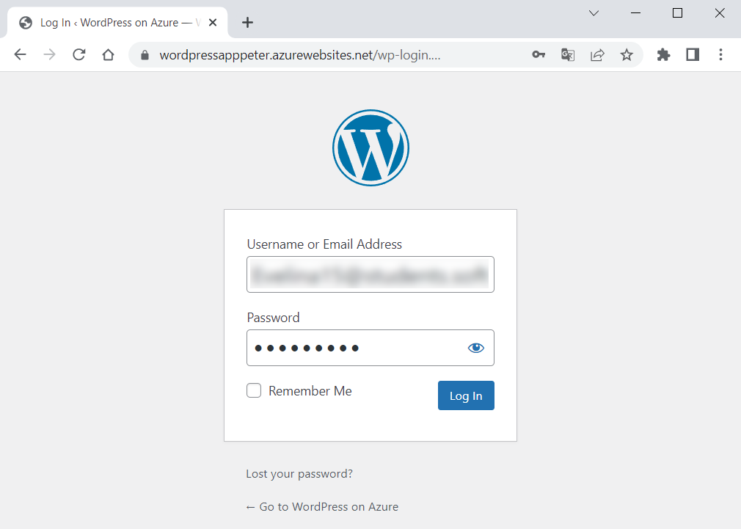
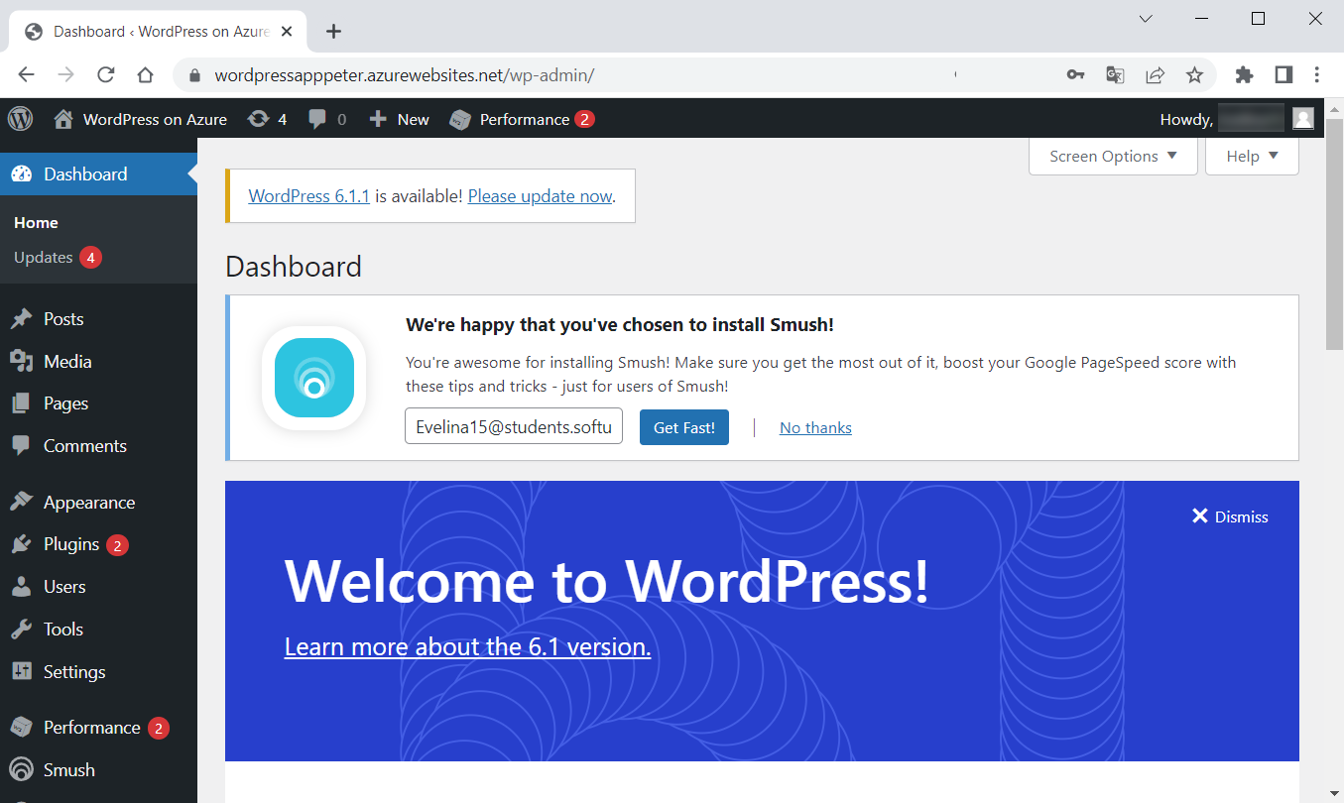

Step 3: Access the Database
You can also access the MySQL Flexible Server database but not directly because it is created behind a private Virtual Network.
To access or manage the database, we should first get its credentials, which are generated automatically. To retrieve these values after the deployment, go to "Application Settings" section of the "Configuration" page in Azure App Service and copy the values of DATABASE_USERNAME and DATABASE_PASSWORD:
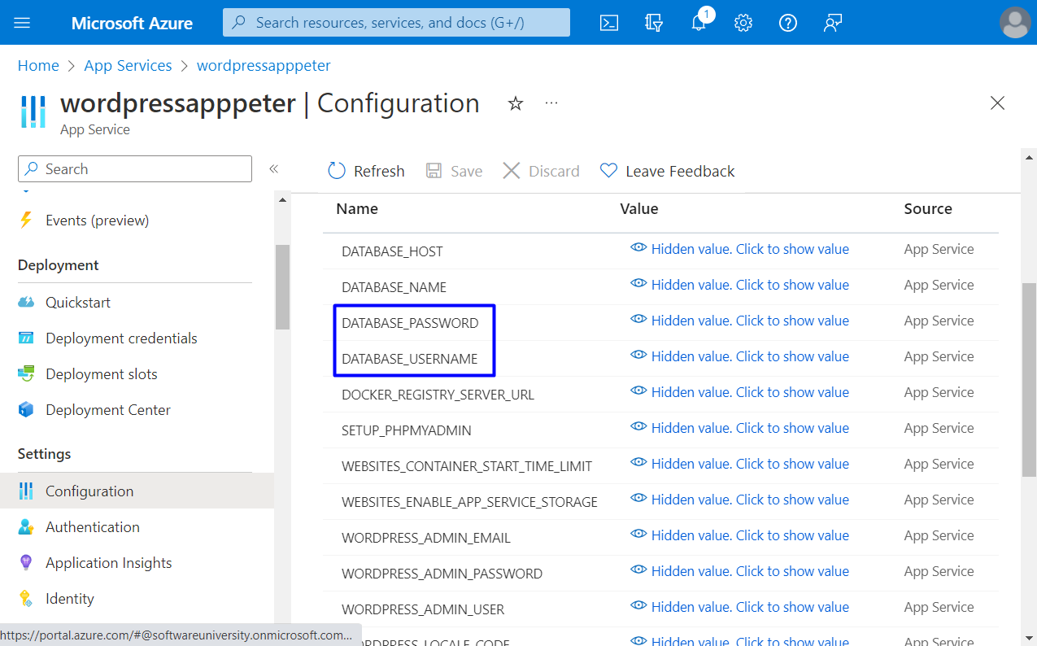
Access the database by using phpMyAdmin that's deployed with the WordPress site: navigate to https://<sitename>.azurewebsites.net/phpmyadmin and log in with the credentials:
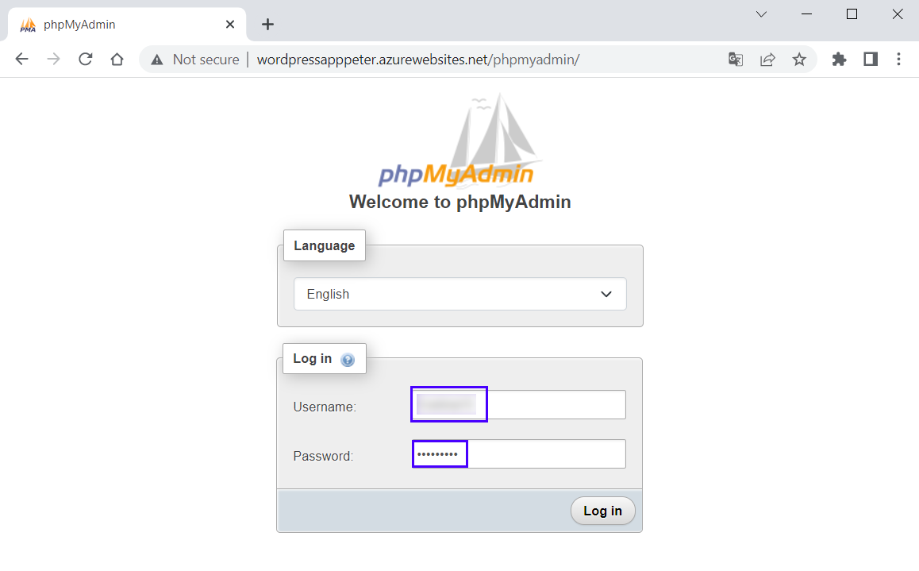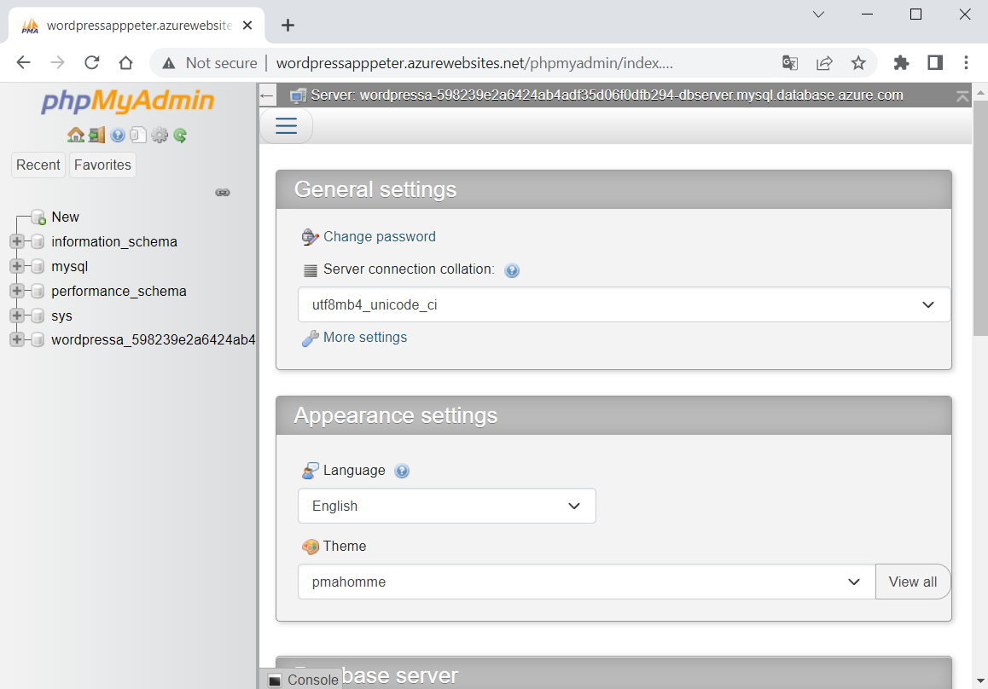
You can explore the database and its tables.

Step 4: Explore App in Azure Portal
In Azure Portal you can see and manage all app resources that you created.
Look at the resources on the "All resources" page (you can search for it in the search bar):
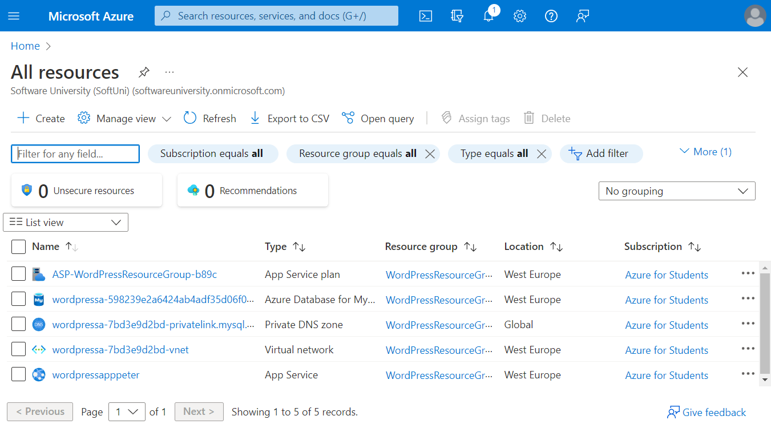
Look at each of resources and explore Azure Portal.

Step 5: Delete App and Clean Up Resources
When you have successfully uploaded your app to Azure and don't need it anymore, it is time to remove it.
You can delete all of the app resources from your Azure subscription by deleting the resource group. Find all resource groups by going to Azure Portal and typing "Resource groups" in the search bar:
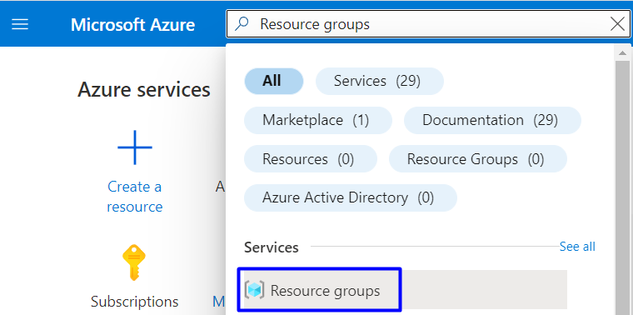
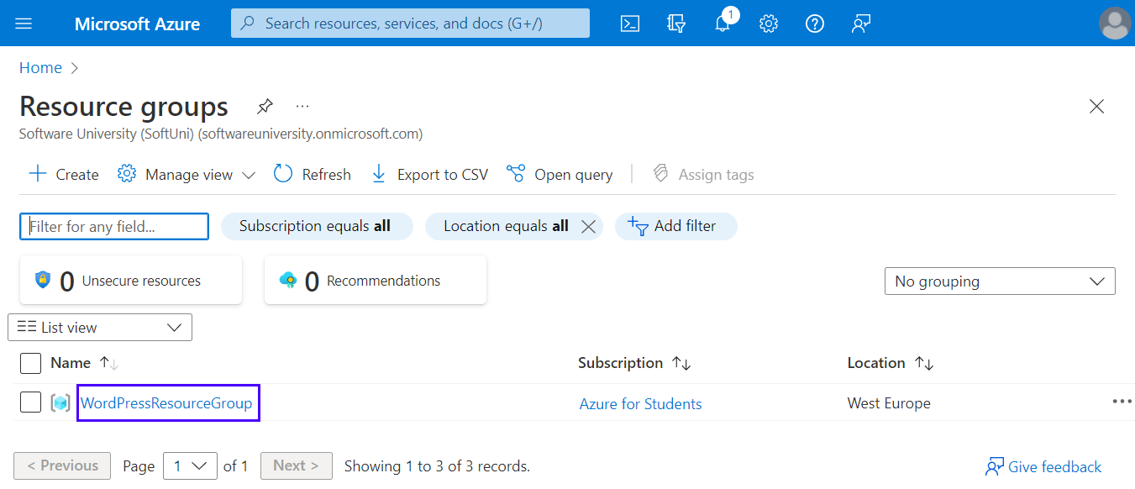
You have your "WordPressResourceGroup" group. Delete it by selecting [Delete resource group]:
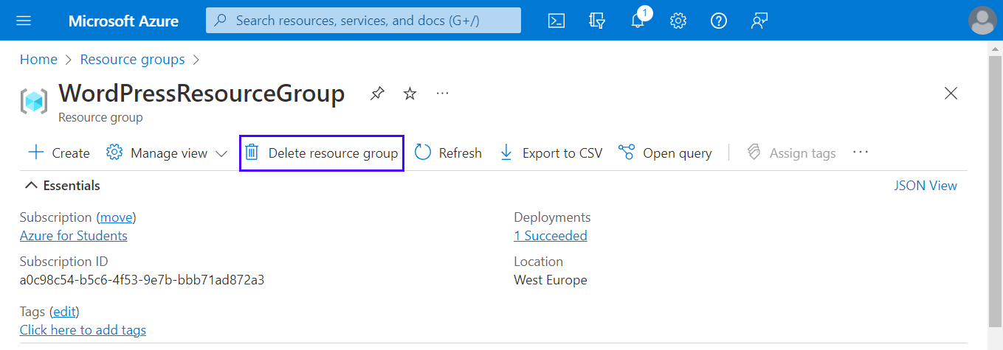
Next, type the resource group name and click [Delete]:
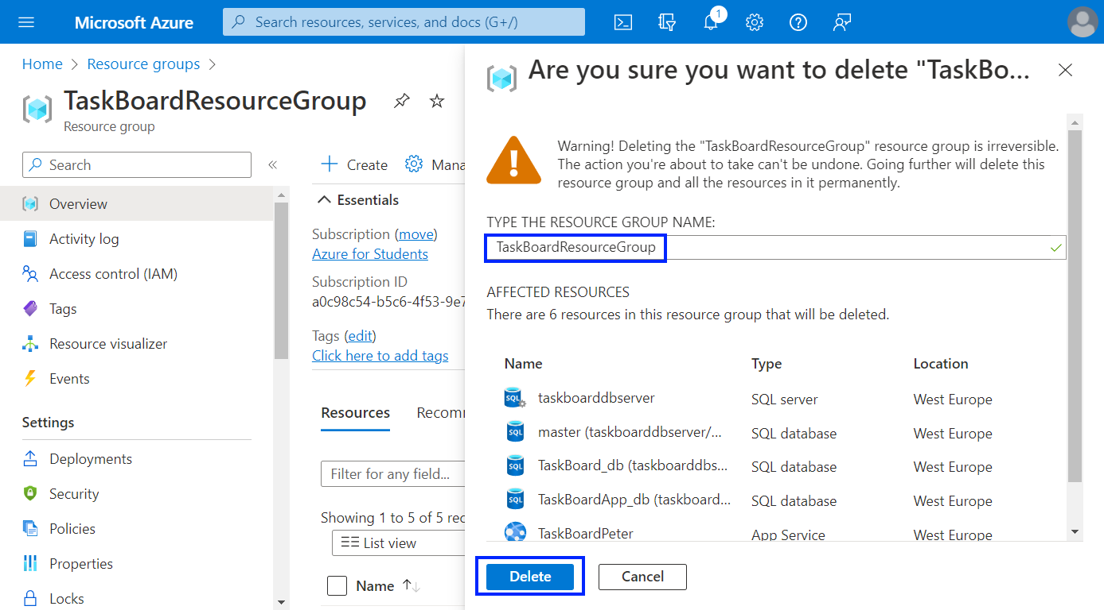
The resource group will be deleted after a while. All resources of your app will be deleted with it.
Now you have a fully-functional WordPress site in Azure and you know how to manage it and its resources.

Deploy a Node.js + MongoDB Web App to Azure
You are provided with a Node.js app with a MongoDB database called "TODO App" in the resources. It looks like this when run:
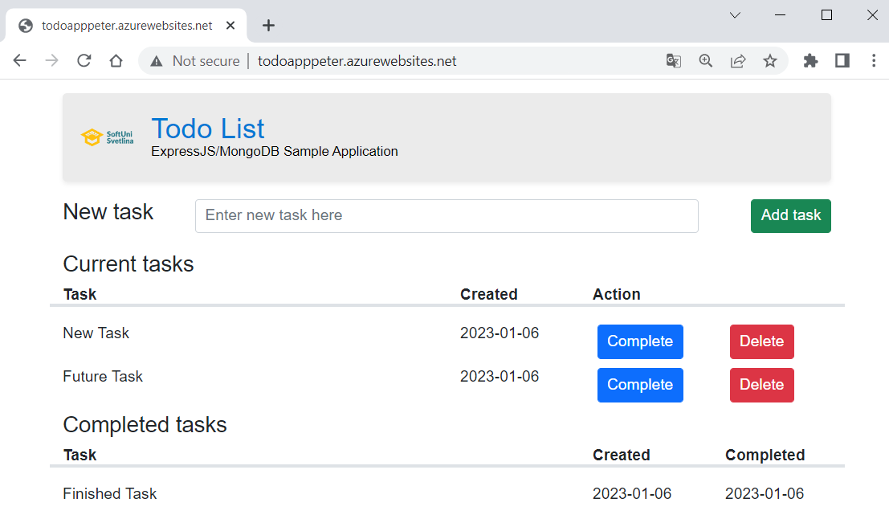
You should upload the app to GitHub, as a start, and then deploy it to Azure, using Azure App Service and Azure Cosmos DB for MongoDB.
The process is pretty similar to deploying an ASP.NET app with a SQL database – the only difference is the settings of the app.

Hints
You should fulfill the below steps to run the app in Azure:
- Upload the "TODO App" project code from the resources to a GitHub repository.
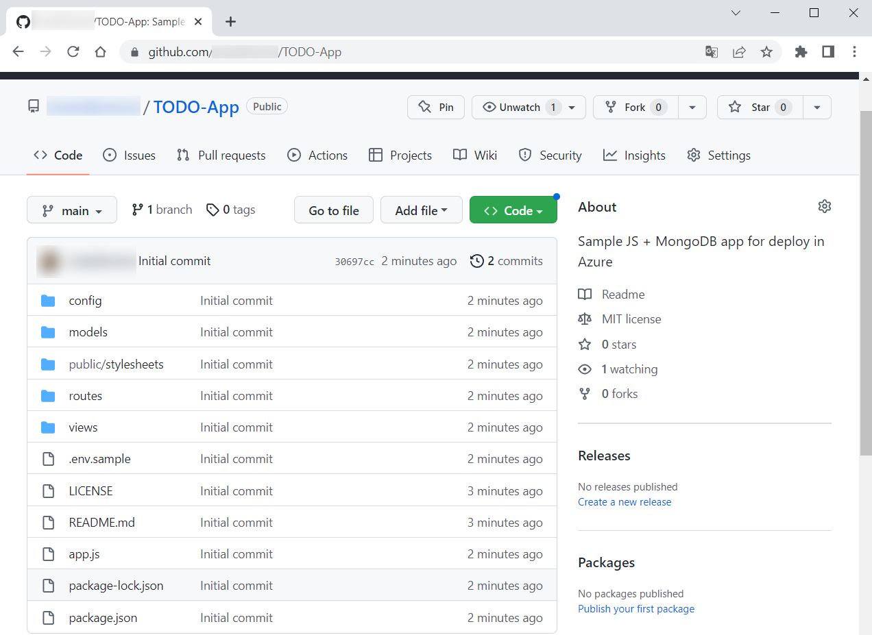
- In Azure Portal, go to the "Create Web App + Database" page and fill in the fields. Create a new resource group. Give a suitable name to the Azure app. Choose [Node 18 LTS] as runtime stack. Don't change the default selected database engine (Cosmos DB API for MongoDB) and copy the generated database name because you will need it later.
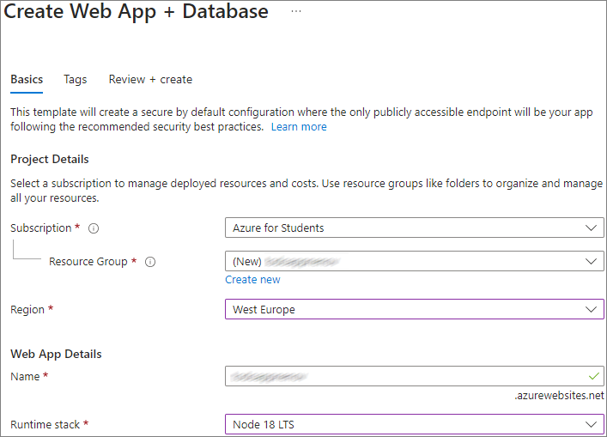
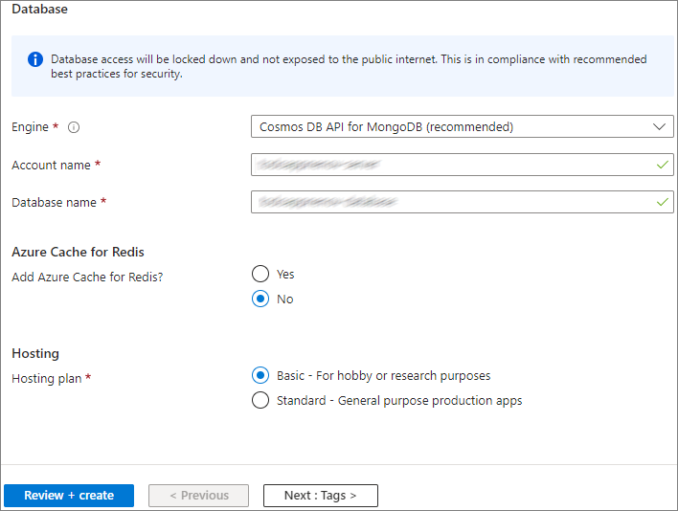
- Go to the "Configuration" page of the App Service app and create a [New application setting] with:
  - Name: "DATABASE_NAME"
  - Value: the automatically generated database name you copied earlier (i.e. <app-name>-database)
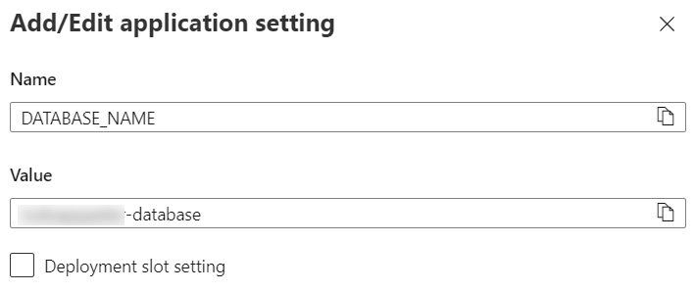
- Next, select the "MONGODB_URI" connection string on the same page and copy its value
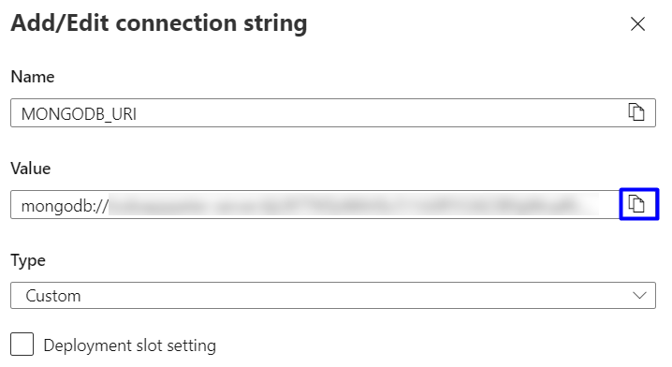
- Create one more new application setting with:
  - Name: "DATABASE_URL"
  - Value: the "MONGODB_URI" connection string you copied earlier (i.e., mongodb://...)
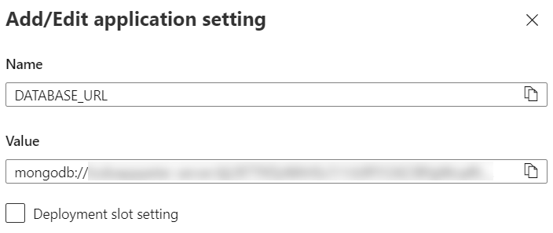
Don't forget to save the settings.
- Your app is configured to work with the Azure database, so you should just go to the "Deployment Center" page and deploy the app from the GitHub repository.
- A GitHub workflow should be created and it should show a status of "Complete". It takes about 15-30 minutes.
- You should be able to access the app on https://<app-name>.azurewebsites.net and work with it.
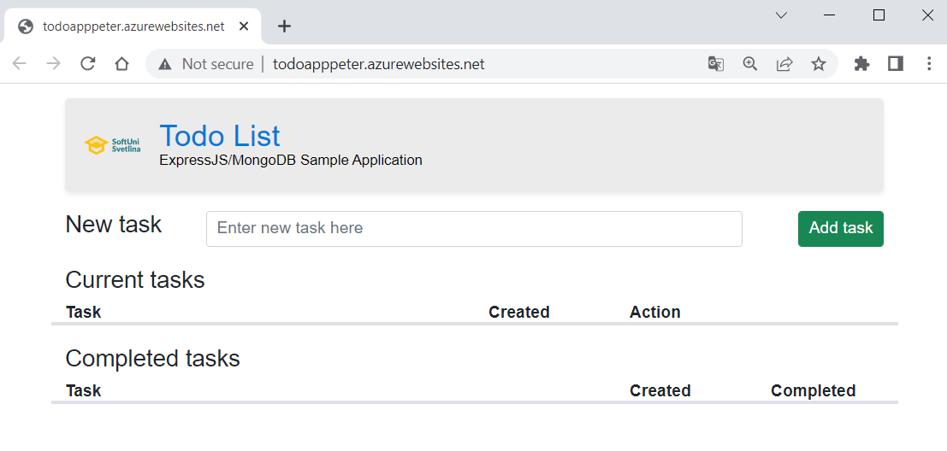
NOTE: Don't forget to delete the resources in your Azure account.

Deploy NGINX Server Container to Azure using Azure Portal
In this task, we will deploy a container instance to Azure Container Instances using the Azure Portal. Azure Container Instances allows us to run serverless and isolated Docker containers in Azure and make its application available with a fully qualified domain name (FQDN).
We will use the NGINX server image from DockerHub: https://hub.docker.com/r/nginxdemos/hello. You are already familiar with the server. When deployed to Azure, it will look like this:
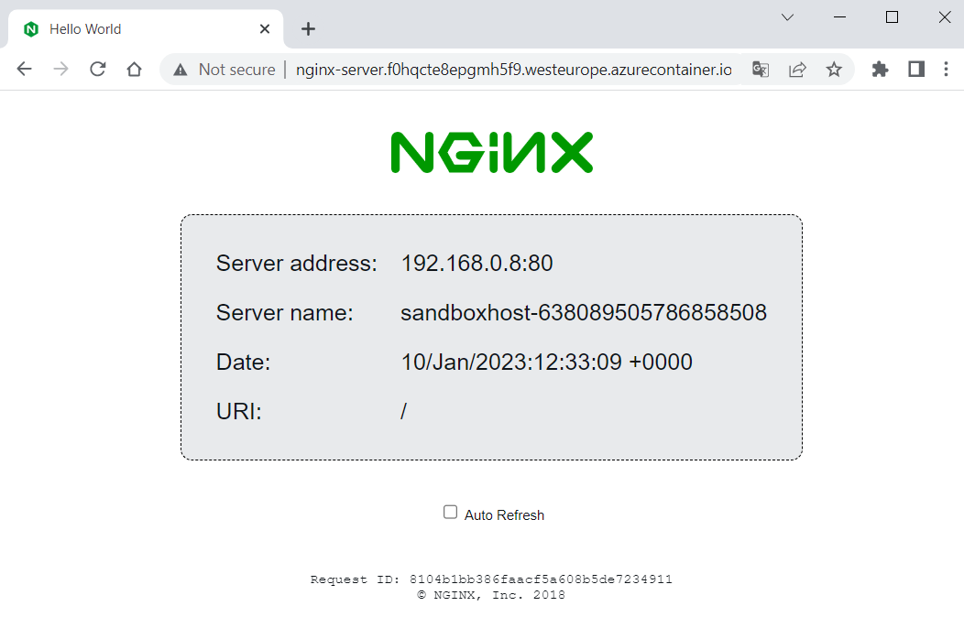
Let's see how to do this. As a first step, open Azure Portal (https://portal.azure.com) and click on [Create a resource]:
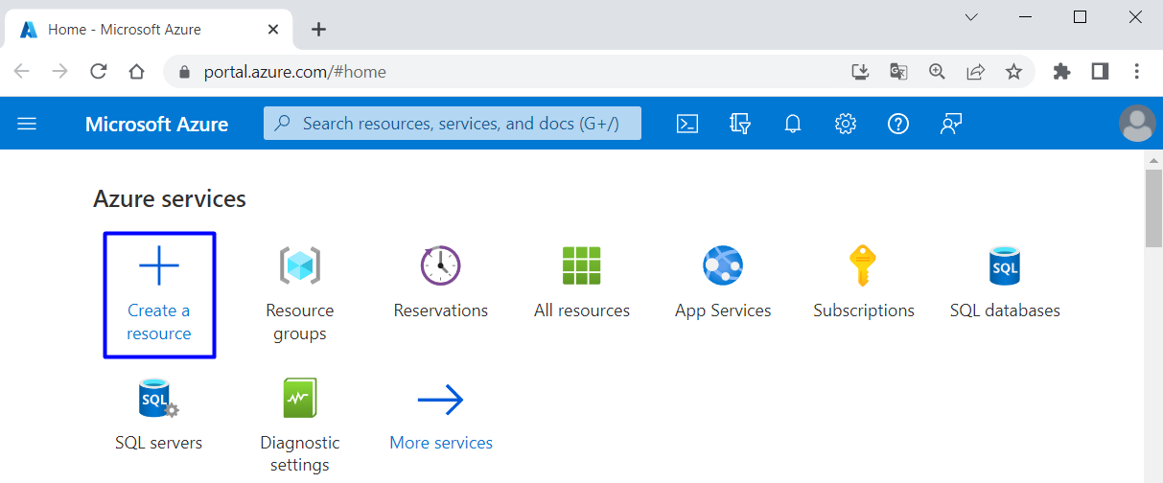
Next, choose [Containers] [Container Instances]:
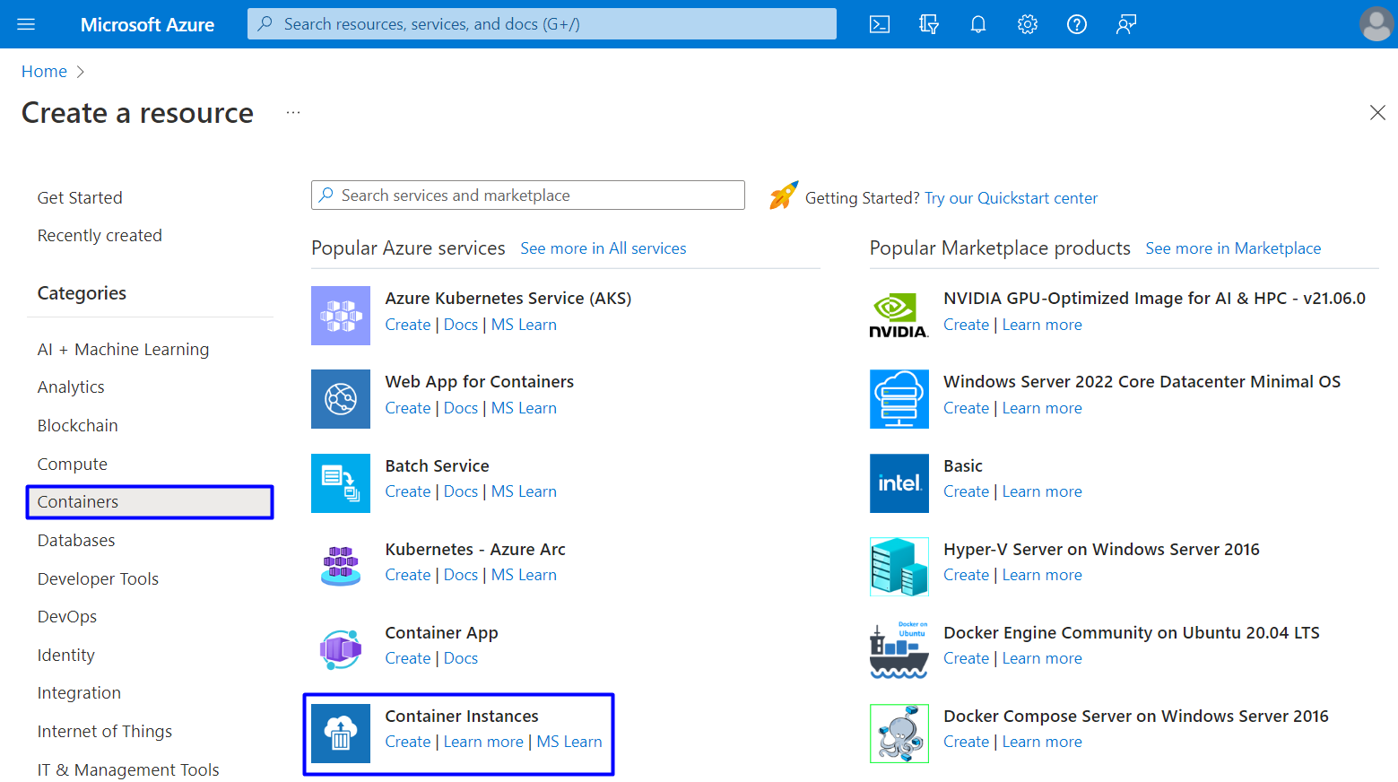
On the "Basic" tab of the "Create container instance" page you should fill in the fields as follows:
- Use your "Azure for Students" subscription
- Create a new resource group with a suitable name
- Create a name for your container
- Choose a region near you
- Leave the "Availability zones" to [None]
- For the image source, choose [Other registry] (to use an image from DockerHub, which is the default registry for this option) and fill in the image name
- Leave the "OS type" to [Linux] and "Size" field with the given options
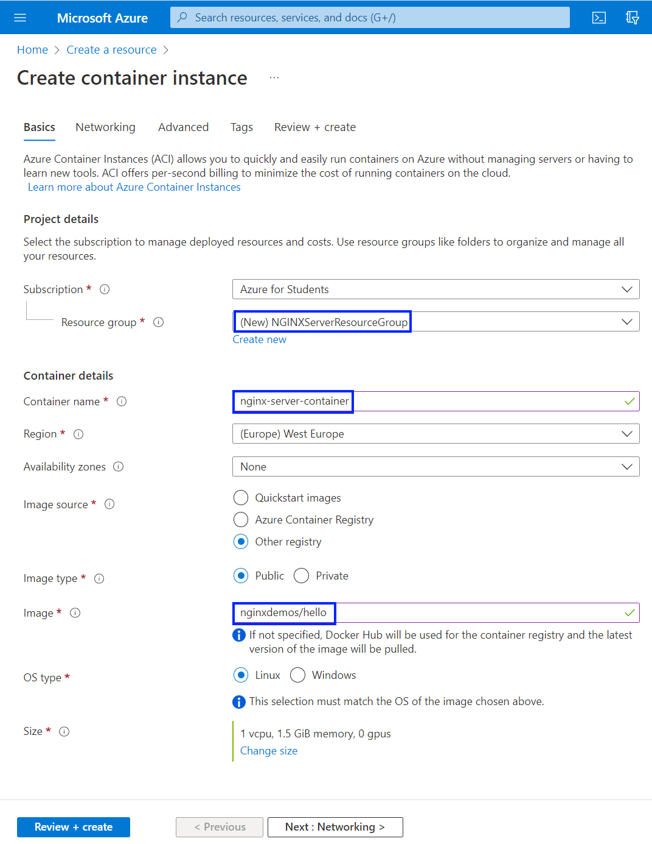

Click on [Next] to go to the "Networking" tab. There you should fill in a DNS name for your container and choose [Tenant] for DNS scope reuse:
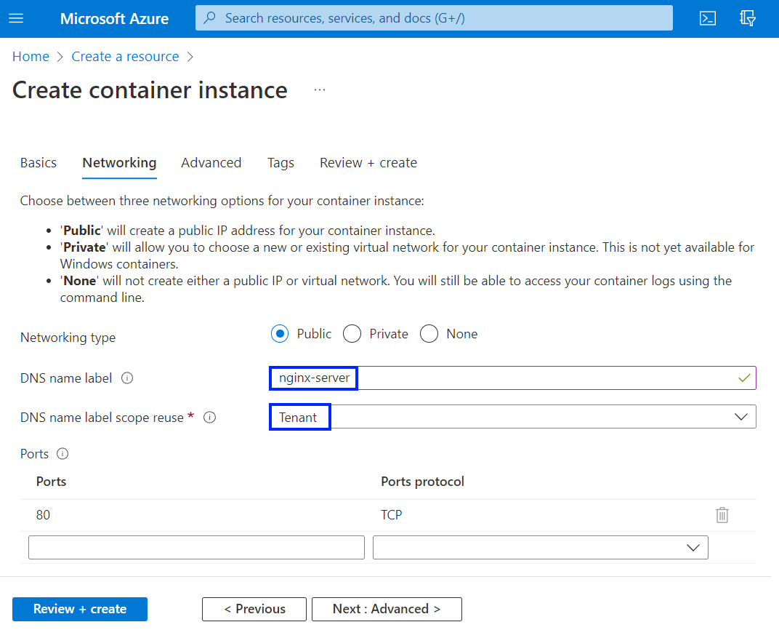
The name must be unique within the Azure region where you create the container instance. Your container will be publicly reachable at <dns-name-label>.<region>.azurecontainer.io. An auto-generated hash is added as a DNS name label to your container instance's fully qualified domain name (FQDN).
If you receive a "DNS name label not available" error message, try a different DNS name label.
Leave all other settings as their defaults and select [Review + create], then [Create]. Wait for the deployment to complete:
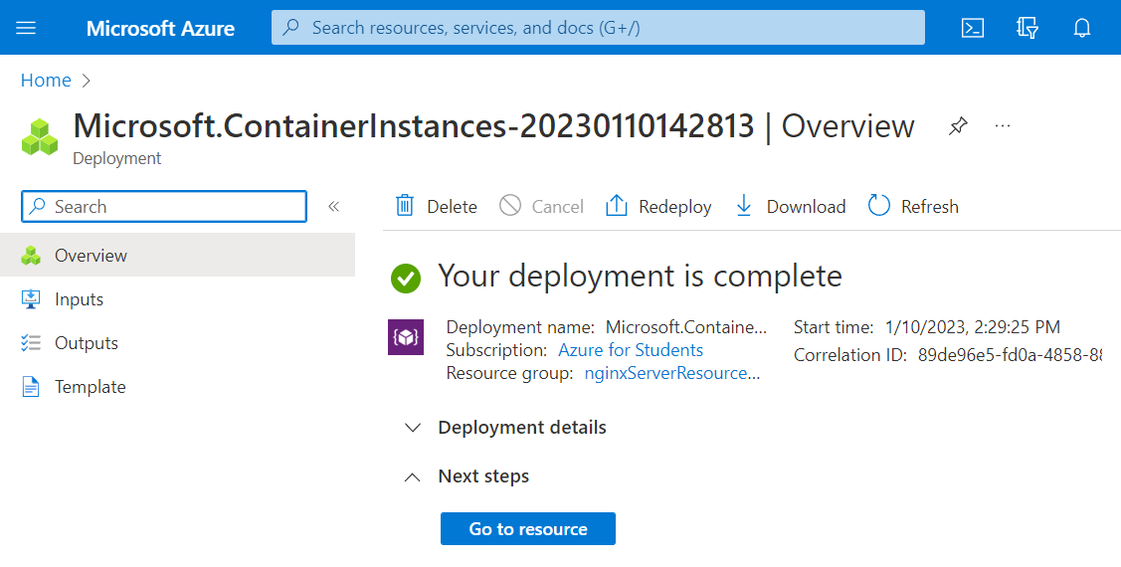
Then go to nginx-server container instance from the "Container instances" page:
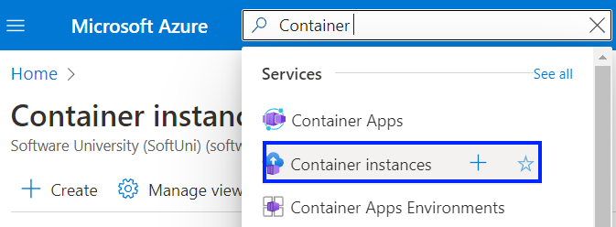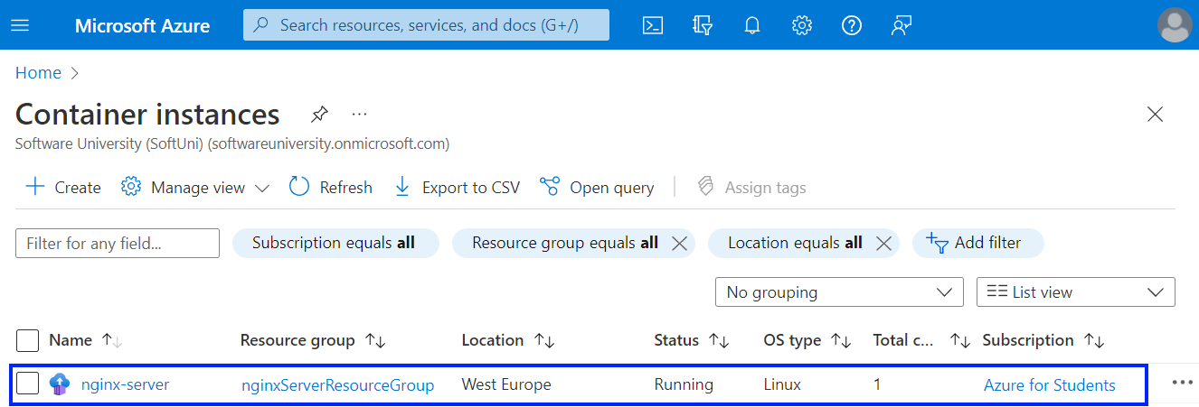
Look at the FQDN and the status of the container on the "Overview" page:
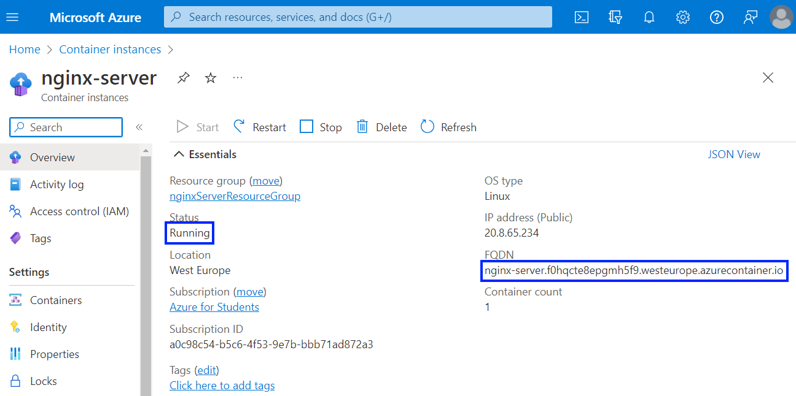
When the status is "Running", navigate to the container's FQDN in your browser and you should see your NGINX server:
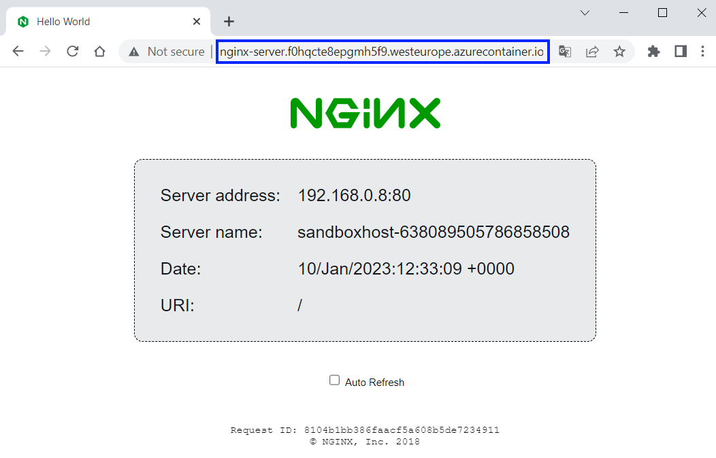
NOTE: if you receive an error, wait for the container a little bit more. After up to 5 minutes, it should be loading successfully.
If you have any other problems, you can look at the container logs in [Containers] [Logs]:
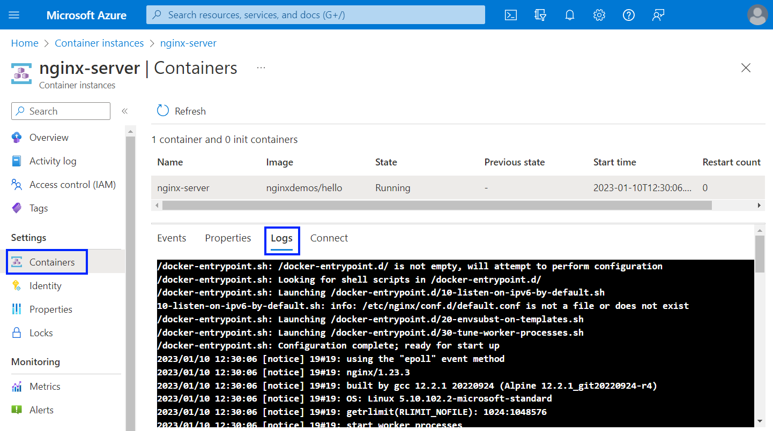
You can delete the container by deleting its resource group in the familiar to you way. You can also delete only the container by going to [Overview] and clicking on [Delete]:
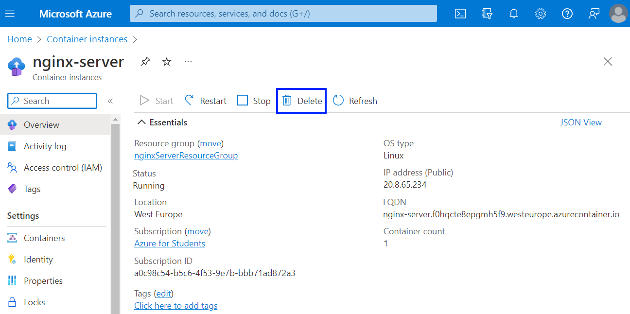

Deploy the "Tracker" App to Azure
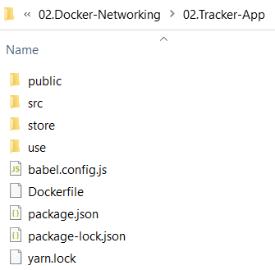
Your task now is to run a simple JavaScript front-end app based on Vue.js for keeping track of daily duties in a Docker container. It does not need anything but an image to run. It does not use a database or any other storage.
You're provided with its files it in the resources, together with a Dockerfile which runs the app on NGINX server (on the right):
You should deploy the app to Azure Container Instances.

Install Azure CLI on Your Local Computer
The Azure Command-Line Interface (CLI) is a cross-platform command-line tool, which can be used to connect to Azure and execute administrative commands on Azure resources. It can be run from inside a Docker container.
Because the Azure Cloud Shell does not include the Docker daemon, you must install both the Azure CLI and Docker Engine on your local computer for this task. We will use it, as well, but later when we are done with Docker.
You already have Docker, so let's install Azure CLI. This can be done through PowerShell with the following command:
$ProgressPreference = 'SilentlyContinue'; Invoke-WebRequest -Uri https://aka.ms/installazurecliwindows -OutFile .\AzureCLI.msi; Start-Process msiexec.exe -Wait -ArgumentList '/I AzureCLI.msi /quiet'; rm .\AzureCLI.msi
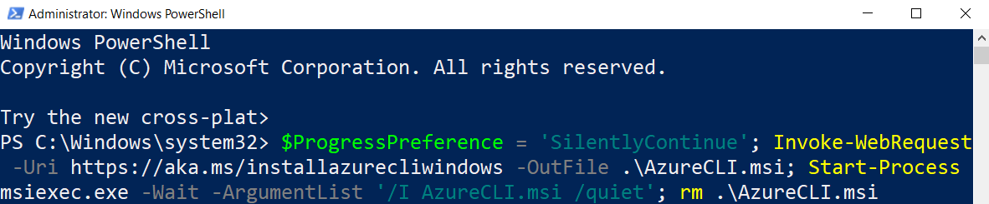
NOTE: PowerShell must be run as administrator for the installation. After that, run a new PowerShell instance in the standard way and work with it.
You can check your Azure CLI version with:
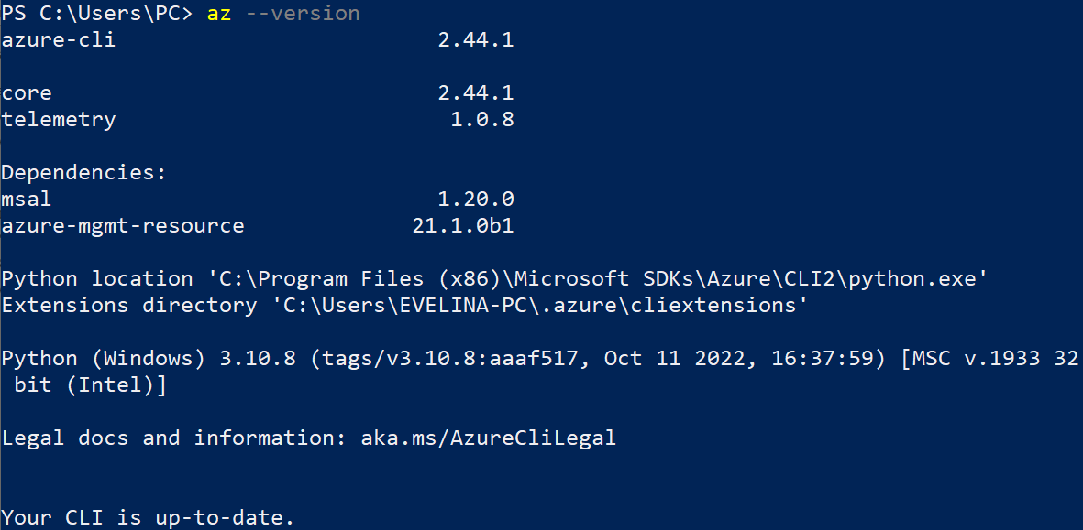
Now you can go on with creating a container image.

Step 1: Create a Container Image for Deployment
In this step, you will package the "Tracker App" into a container image that can be run using Azure Container Instances.
You are provided with a Dockerfile, so you should just create the image, for example "tracker-app-image". You should know how to do it:
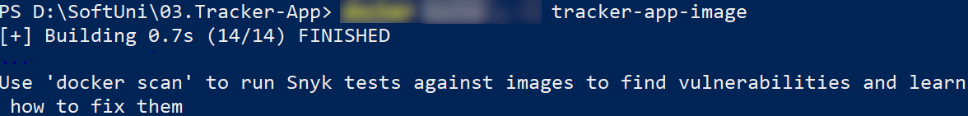
The newly created image should appear:
You can now use this image to run a container locally to see if it works:
↓
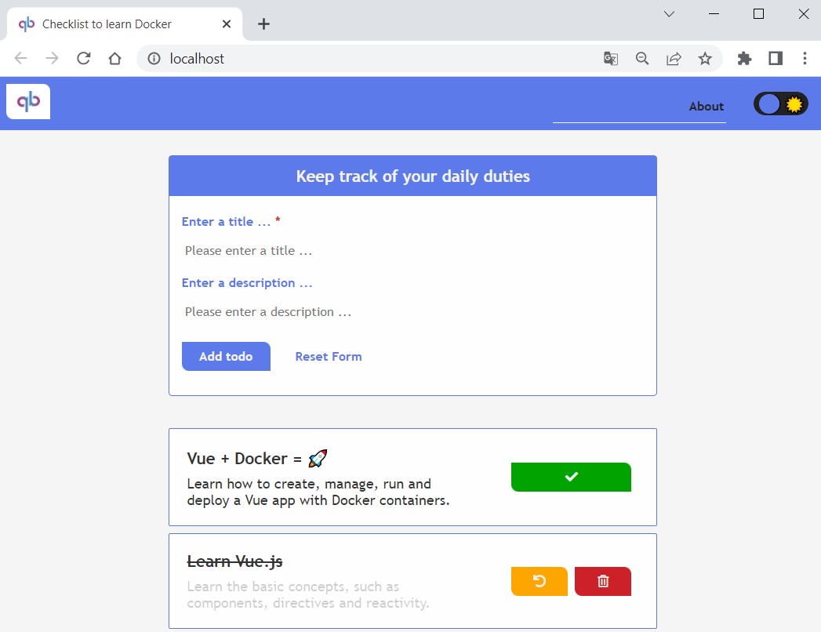
We have verified that the container image runs locally, so let's see how to push it to Azure Container Registry.

Step 2: Create an Azure Container Registry and Push a Container Image
An Azure Container Registry is a managed registry service. It stores and manages private container images and other artifacts, similar to the way Docker Hub stores public Docker container images.
Now we should create an Azure container registry and push our image to it.
First, login to Azure through Azure CLI with the az login command. A web browser will be opened and you should enter your credentials. Then login should be successful:
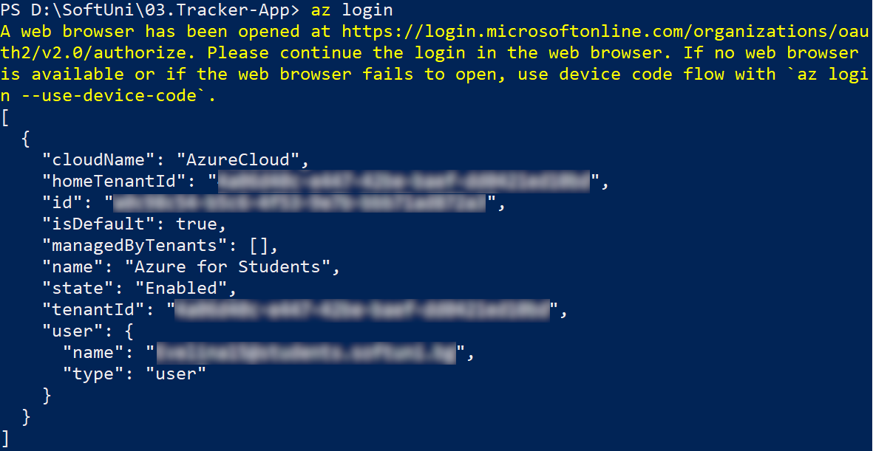

Create Azure Container Registry
Now you need a resource group to deploy the container registry that we will create to.
Create a new resource group in Azure with the az group create command. Name the group in a way you want and set it in the "westeurope" region:
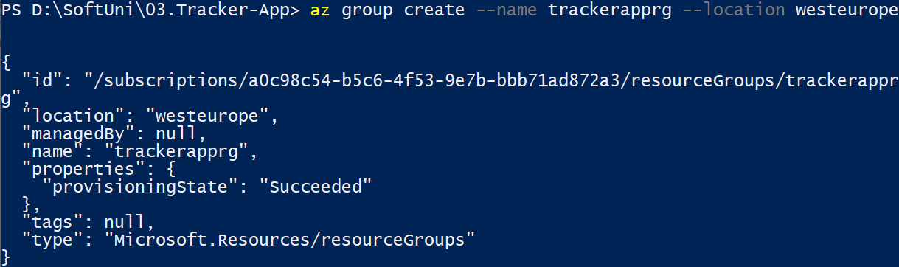
Once you've created the resource group, create an Azure container registry with the az acr create command. The container registry name must be unique within Azure, and contain 5-50 alphanumeric characters:
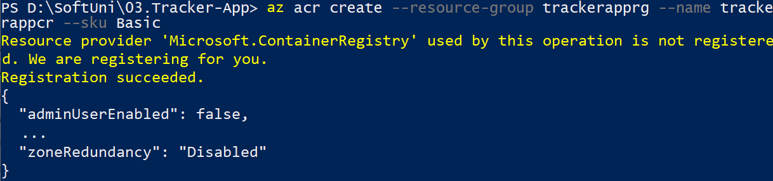
You can also see the container registry in Azure Portal by going to the "Container Registries" page:
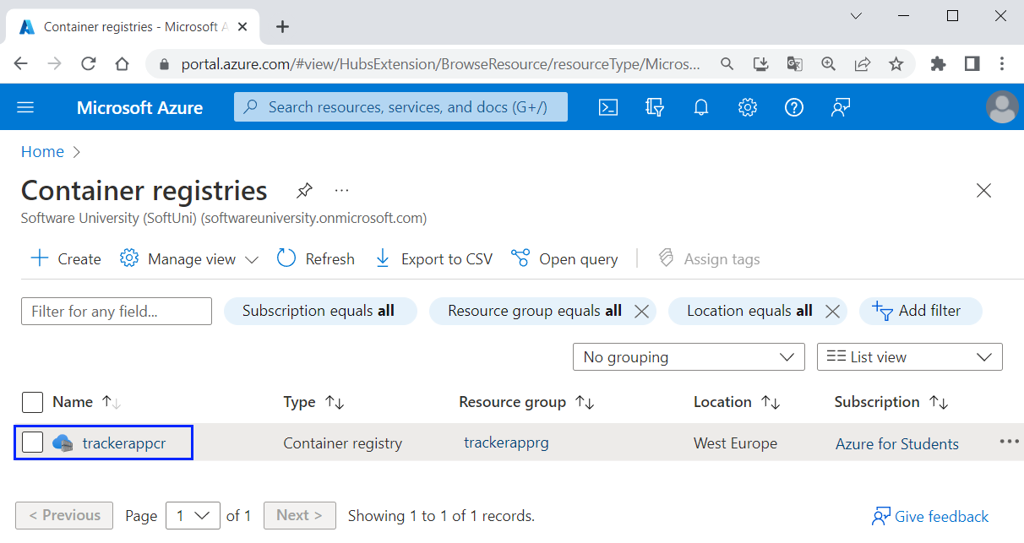
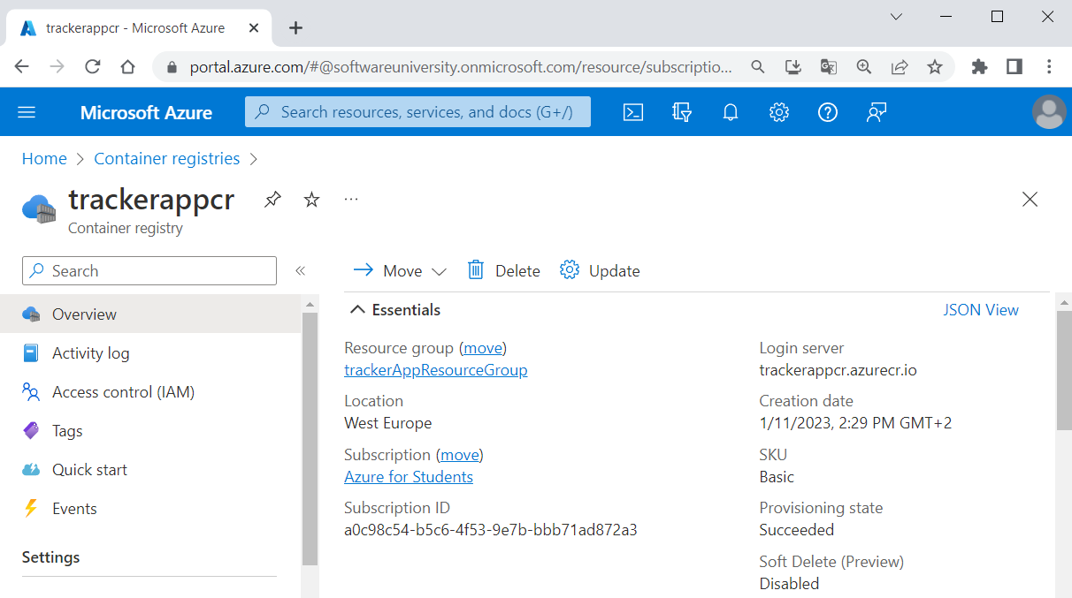
Next, you need to log in to the container registry you created, so that you can push images to it. You should use the az acr login command and provide the name of the registry you created:
Login should be successful.

Tag Container Image
To push a container image to a private registry like Azure Container Registry, you must first tag the image with the full name of the registry's login server.
Get the full login server name for your Azure container registry:
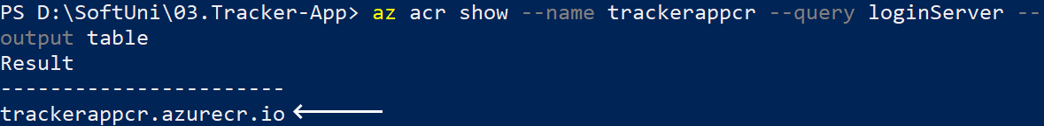
Now you should tag the container image we created in the previous step with the login server of your container registry. Also, add the :v1 tag to the end of the image name to indicate the image version number. Do it like this:
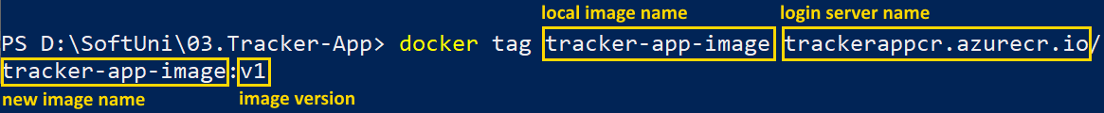
You can look and see that the new image is created:
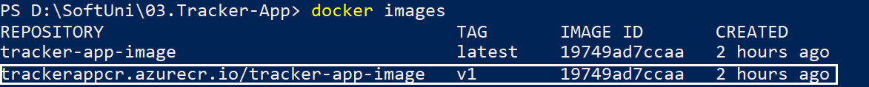
Now you have your image.

Push image to Azure Container Registry
Now you can finally push your new image to Azure Container Registry. Do it as shown below:
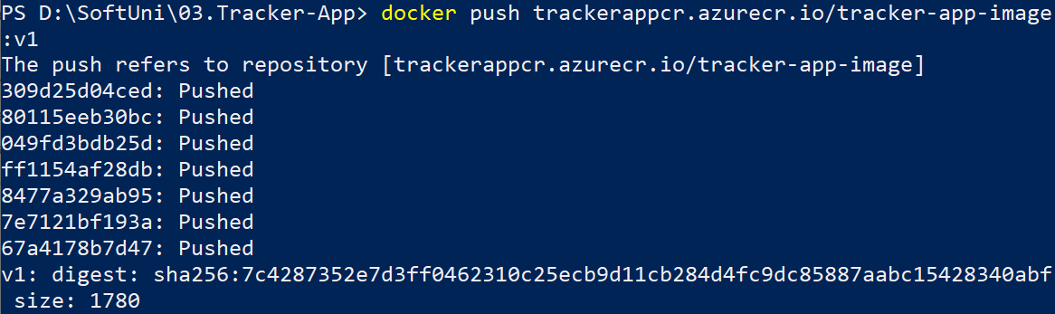
Your image should be pushed successfully. To verify this, list the images in your container registry:
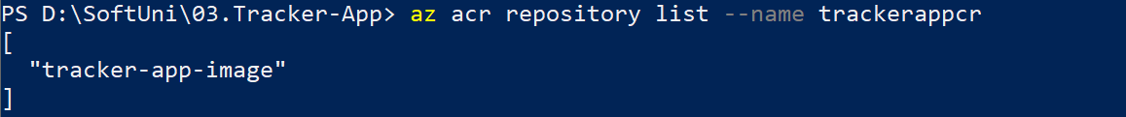
You have you image in Azure Container Registry. You can also check in Azure Portal when you select the container registry [Repositories]:
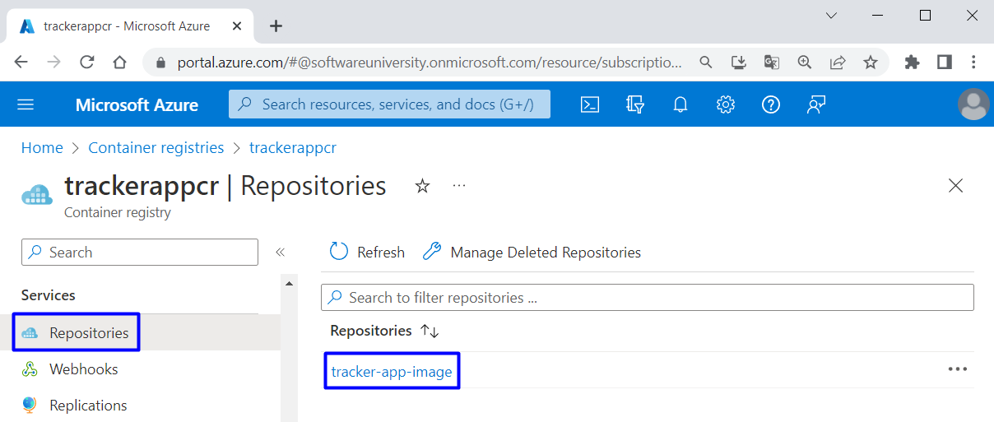
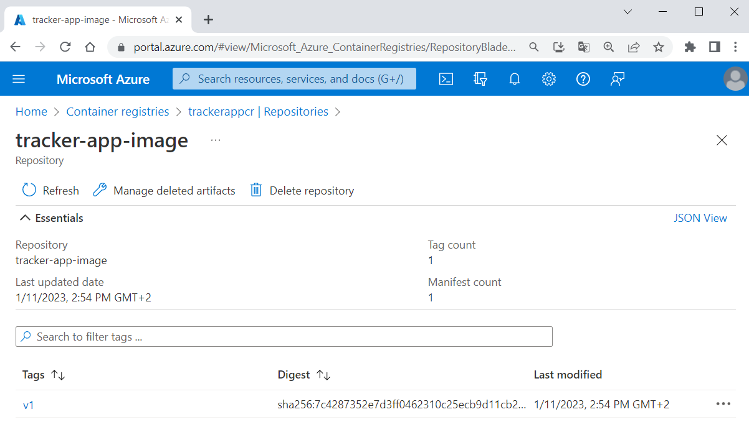
In this step you prepared an Azure container registry for use with Azure Container Instances, and pushed a container image to the registry.

Step 3: Deploy a Container Application
Finally, we have everything needed to deploy a container to Azure Container Instances.

Get Registry Credentials
When you deploy an image that's hosted in a private Azure container registry like the one created, you must supply credentials to access the registry. For this to happen, you shall create and configure an Azure Active Directory (AD) service principal with pull permissions to your registry.
To do this, you will need the following commands:
$ACR_NAME='$containerRegistry'
$SERVICE_PRINCIPAL_NAME='$servicePrincipal'

# Obtain the full registry ID
$ACR_REGISTRY_ID=$(az acr show --name $ACR_NAME --query "id" --output tsv)

# Create and configure the service principal with pull permissions to your registry
$PASSWORD=$(az ad sp create-for-rbac --name $SERVICE_PRINCIPAL_NAME --scopes $ACR_REGISTRY_ID --role acrpull --query "password" --output tsv)
$USER_NAME=$(az ad sp list --display-name $SERVICE_PRINCIPAL_NAME --query "[].appId" --output tsv)

# Output the service principal's credentials
echo "Service principal ID: $USER_NAME"
echo "Service principal password: $PASSWORD"
You should modify them for your environment:
- ACR_NAME should keep the name of your Azure container registry, which you already created
- SERVICE_PRINCIPAL_NAME should keep a new name for your service principal, which should be unique within your Active Directory tenant
Execute the commands one by one with the changes:
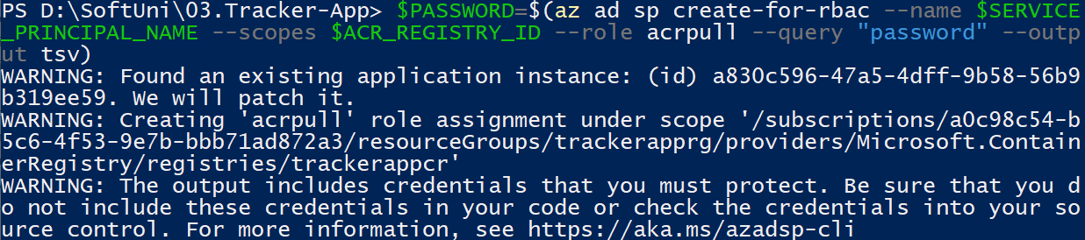
You should have no errors and finally you should have your service principal id and password. Once you have these credentials, you can configure your applications and services to authenticate to your container registry as the service principal. Copy them because you will need them.
NOTE: If you get the "Insufficient privileges to complete the operation." error message, go to "Container registries" in the Azure Portal and select the trackerapp container registry:
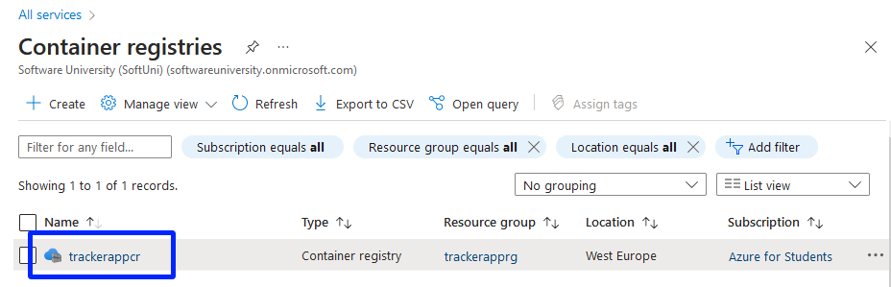
After that, select Access keys and enable the Admin user:
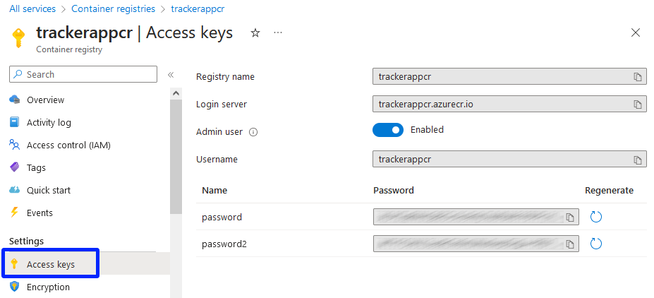

Deploy Container
Now use the az container create command to deploy a container in Azure. Use this command and replace <resource-group-name>, <image-name>, <acrLoginServer>, <service-principal-ID> and <service-principal-password> with your corresponding values. Also, replace <container-name> with a name for your container and <aciDnsLabel> with a new DNS name that you like:
az container create --resource-group <resource-group-name> --name <container-name> --image <acrLoginServer>/<image-name>:v1 --cpu 1 --memory 1 --registry-login-server <acrLoginServer> --registry-username <service-principal-ID> --registry-password <service-principal-password> --ip-address Public --dns-name-label <aciDnsLabel> --ports 80
NOTE: If you have enabled the Admin user in the previous step, just replace <service-principal-ID> with <username> and <service-principal-password> with <password>
Container deployment should be successful:
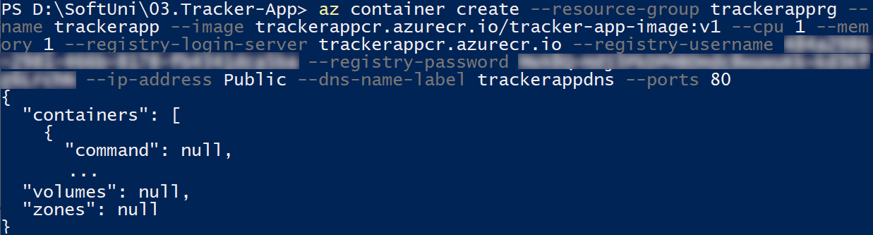
To view the container state of deployment, use:
Once the deployment succeeds, display the container's fully qualified domain name (FQDN):
Use the FQDN to access your app in the browser (it contains the DNS label you chose):
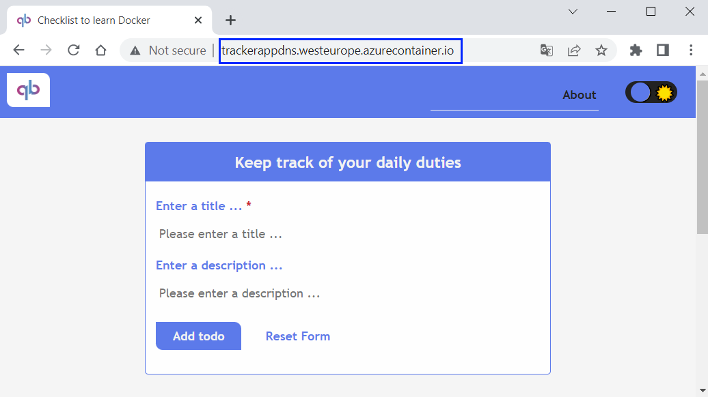
It should be fully working.

Explore and Remove Container
You can look at the created container instance in Azure Portal too:

Deploy TaskBoard App to Azure through Azure Portal
In this task, we will deploy the TaskBoard ASP.NET app to Azure App Service and connect to an Azure SQL Database again, but this time it will be through Azure Portal. We will use Azure + GitHub integration, which enable linking between the code in the repo and the Azure app in production and use of GitHub Actions workflows.

Step 1: Upload Project to GitHub
The first step is to upload the "TaskBoard" project code from the resources to GitHub. Do it in a way you like. When ready, it should look like this:
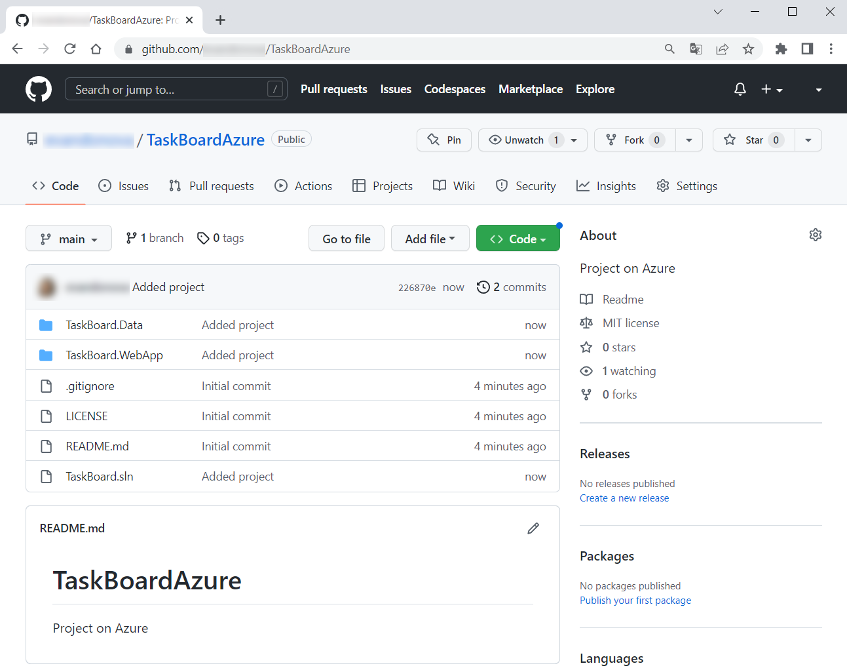
Now we are ready to start working with Azure.

Step 2: Create Azure Resources
In this step, we will create the Azure resources that our app needs – App Service and Azure SQL Database, from Azure Portal. Log in to Azure Portal.
In the search bar, type and select the "Web App + Database" item from the Marketplace:
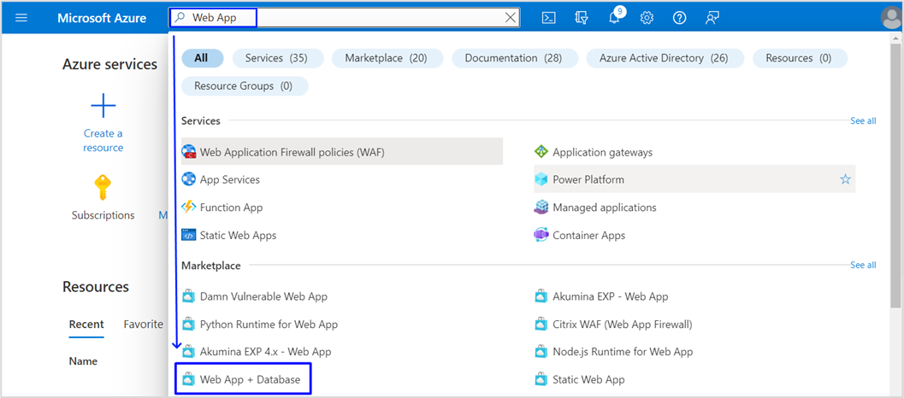
In the "Create Web App + Database" page, fill in the fields. You should:
- Not change the subscription
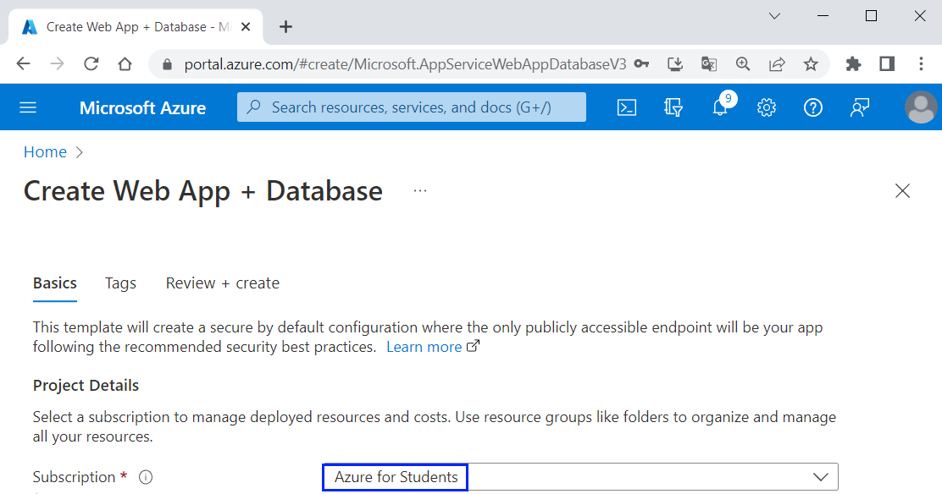
- Create a new resource group named "TaskBoardResourceGroup"
- Choose a region near you, for example [West Europe]
- Set a unique name for your Web app – you can use "TaskBoard{your name}":
- Choose [.NET 6 (LTS)] for runtime stack because the TaskBoard app is written on it:
- Make sure that database data (filled in by default) is correct: database engine should be "SQL Azure" and server and database names should be suitable:
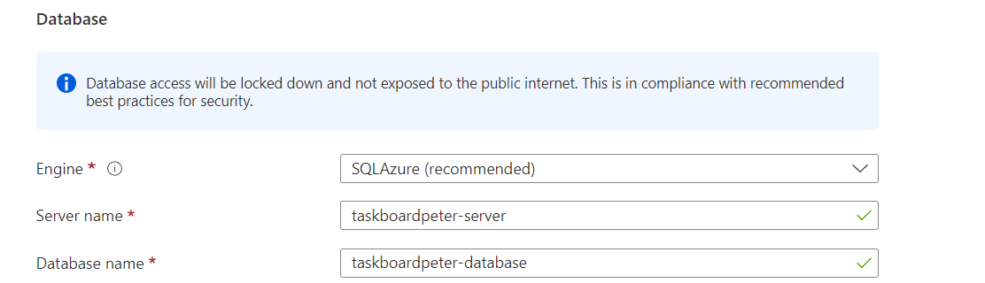
- Choose a "Basic" hosting plan:
- Now click [Review + Create]:
Finally, click [Create]:
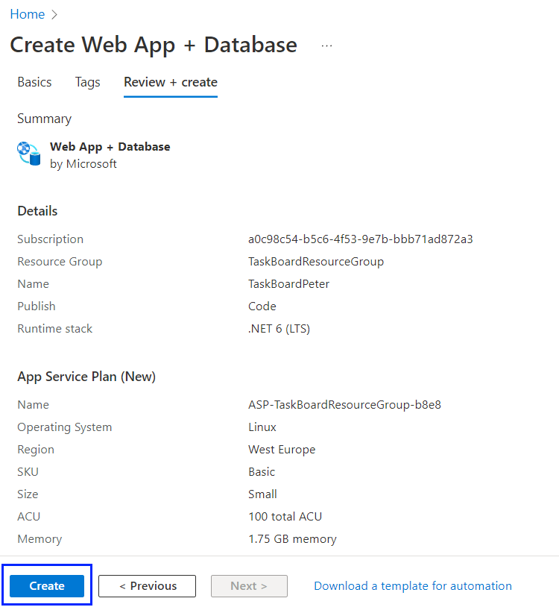
Wait until the deployment is complete and click on the [Go to resource] button:
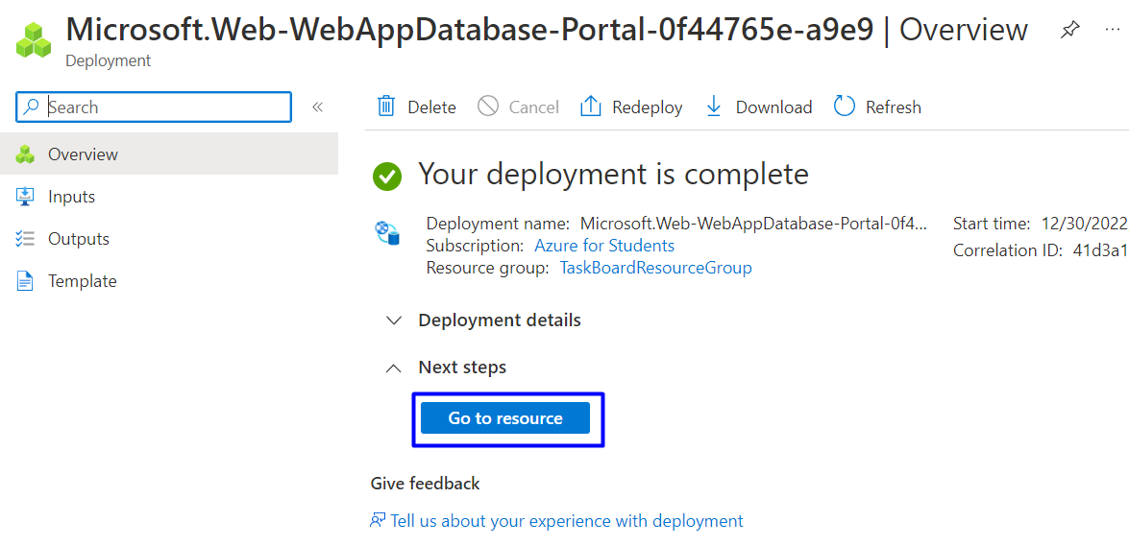
You can look at the App Service app you created:
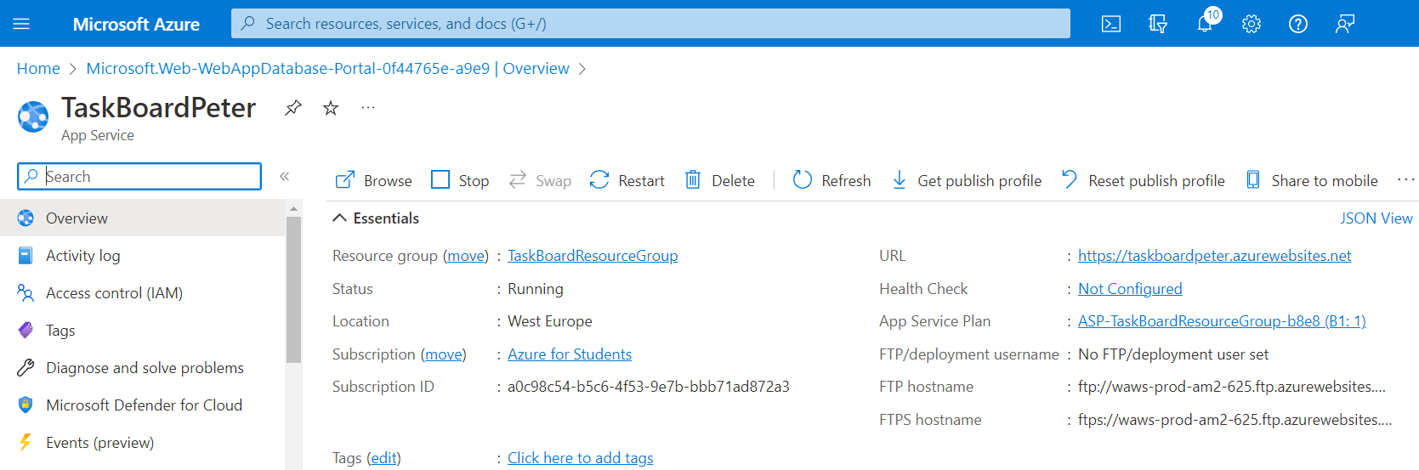
And you can go to the "All Resources" page and look at the created resources:
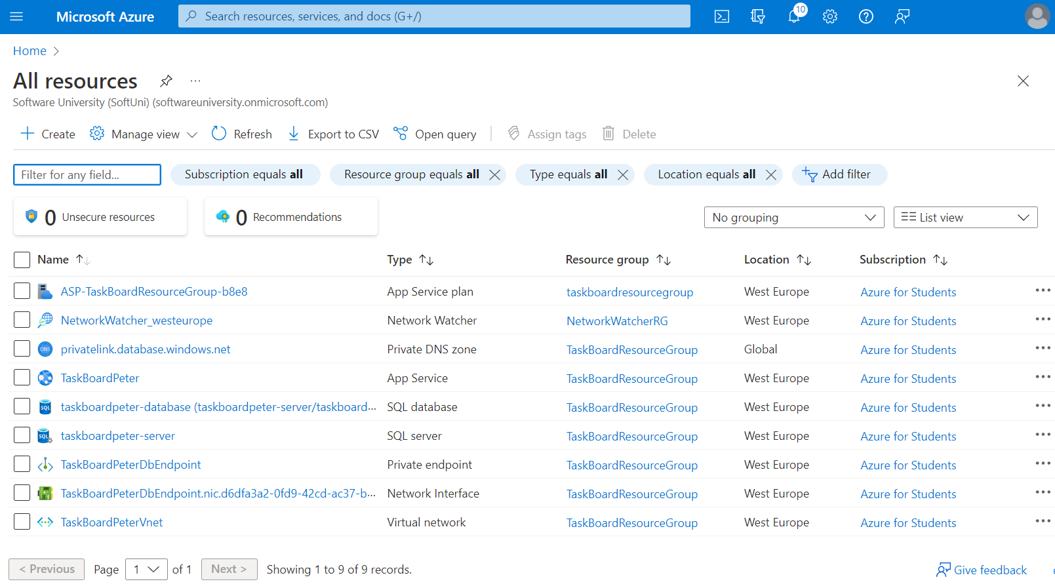
You may notice that they are a lot more than when we added the same app from Visual Studio.

Step 3: Set Up Database Connectivity
You already have a connection string generated for you. You will need it to set it so your app and the database in Azure can connect successfully.
To access the connection string, go back to the "App Service" page of your app [Configuration], scroll to "Connection strings" and click on the connection string you have:
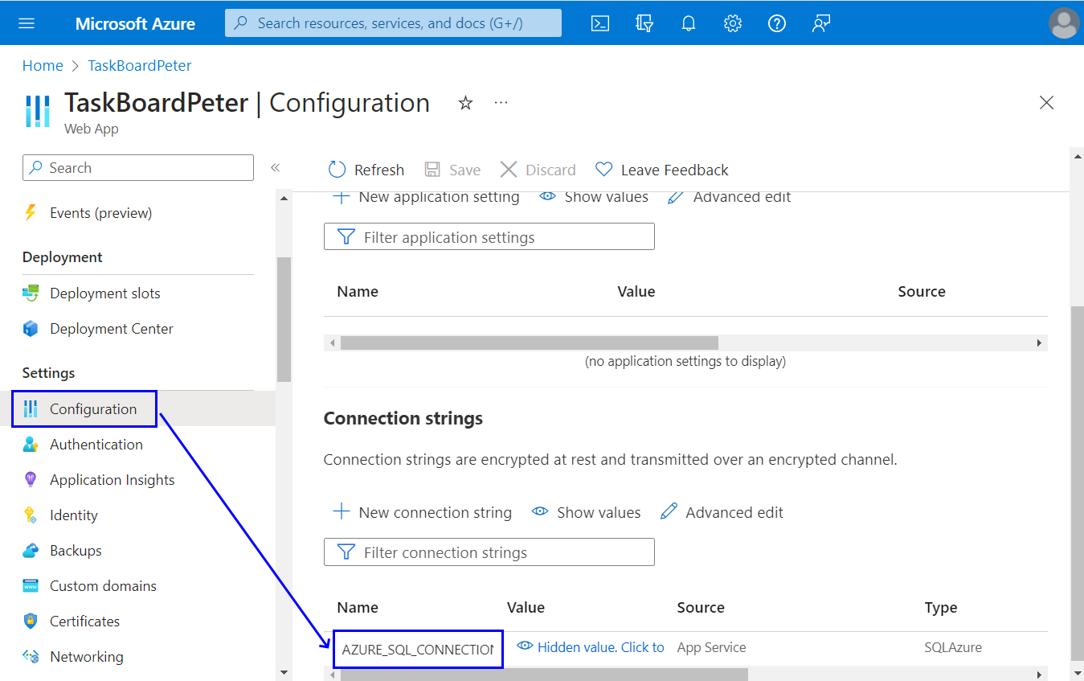
Now change the "Name" variable value to the one from your app's appsettings.json file – in our case it's "DefaultConnection":
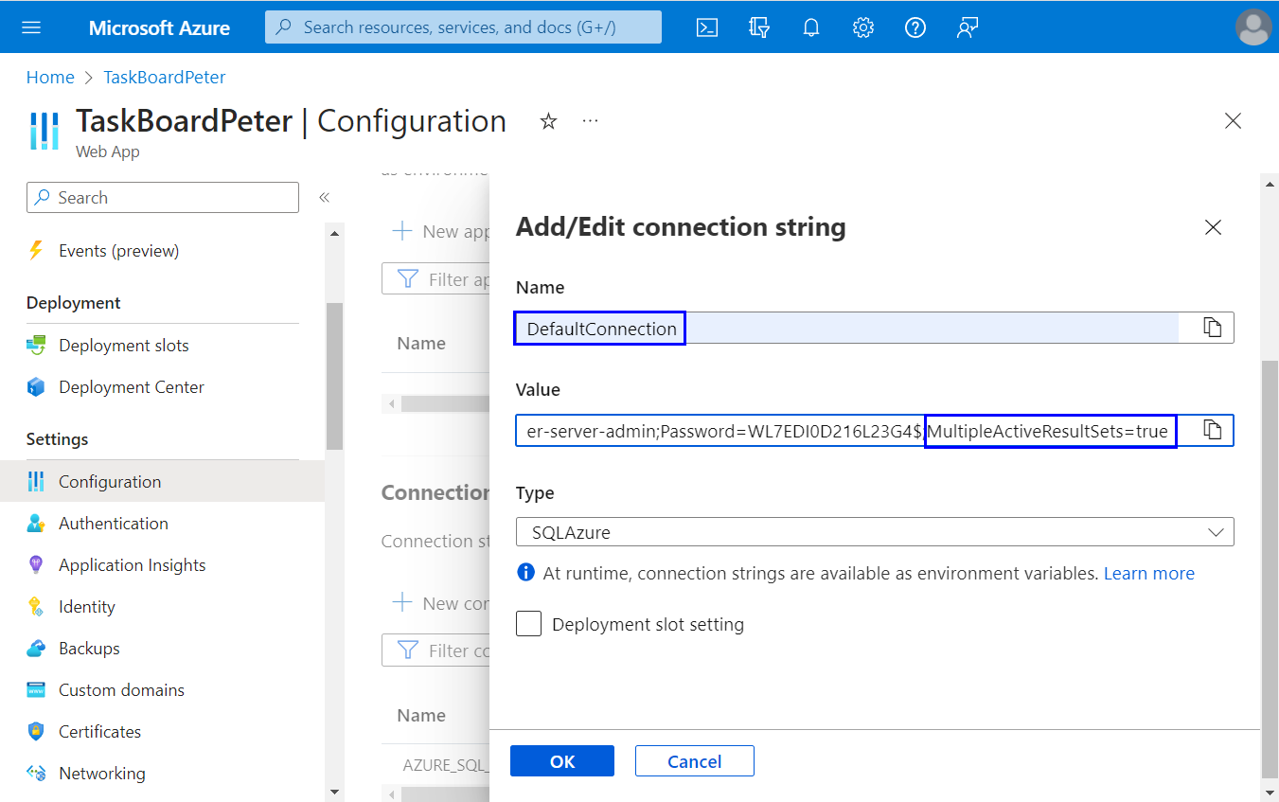
Also, add MultipleActiveResultSets=true at the end of the connection string to allow the execution of multiple batches on a single connection.
Then click on [OK] and [Save] to update Web app settings.

Step 4: Deploy Code
It's time to deploy the TaskBoard app's code from GitHub to Azure. When ready, your changes to the GitHub repo will be reflected in the Azure app in production.
Go to the "App Service" page [Deployment Center]:
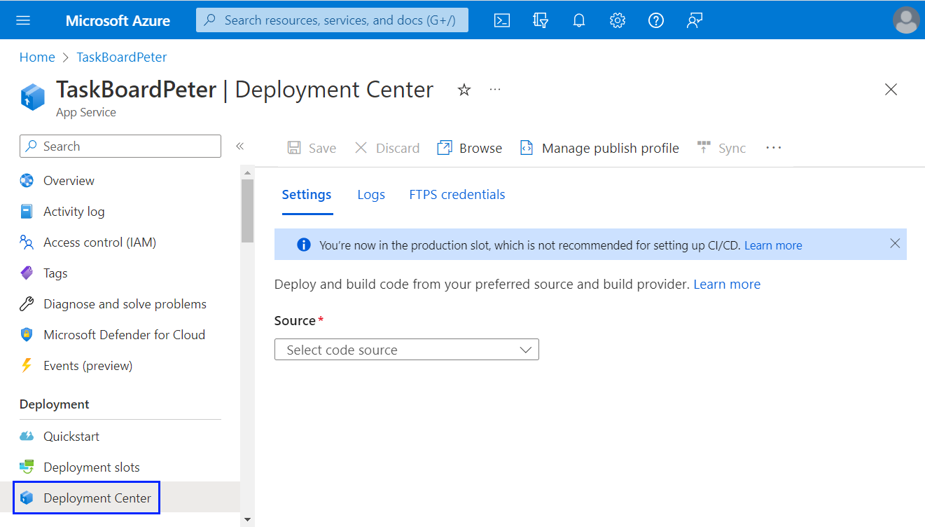
For "Source", choose [GitHub] and sign in with your GitHub account:
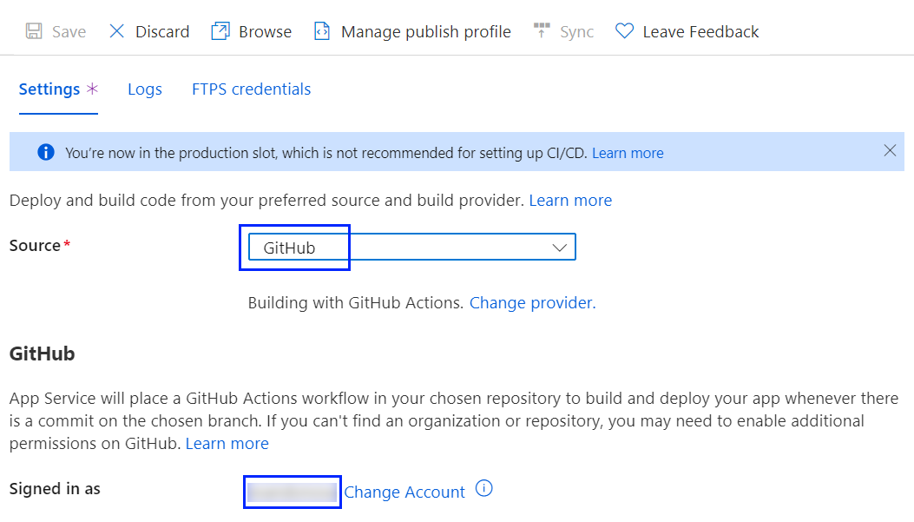
Then choose the organization of your project (your profile), the repository you created and the main branch:

Now click on [Save] to save the changes:
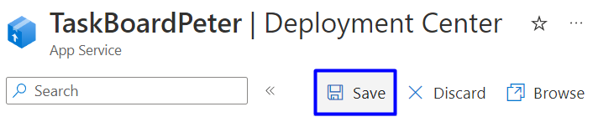
And in GitHub Actions, you have a running workflow, which should be successful after a few minutes.
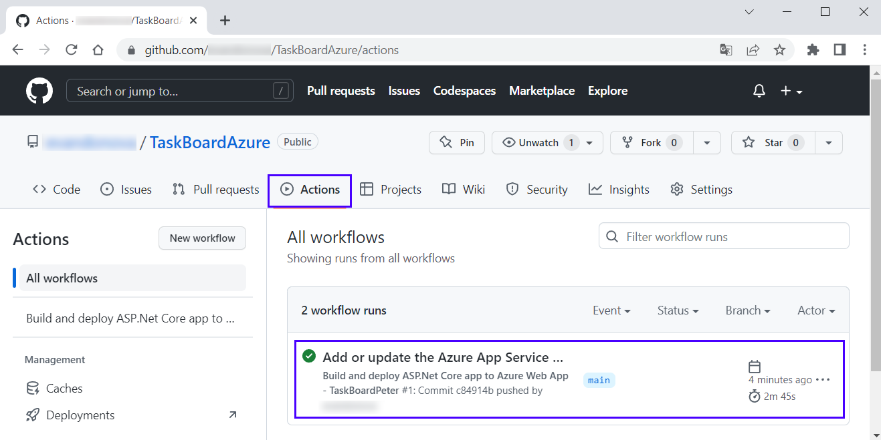
Notice that the workflow file defines two separate stages, build and deploy:
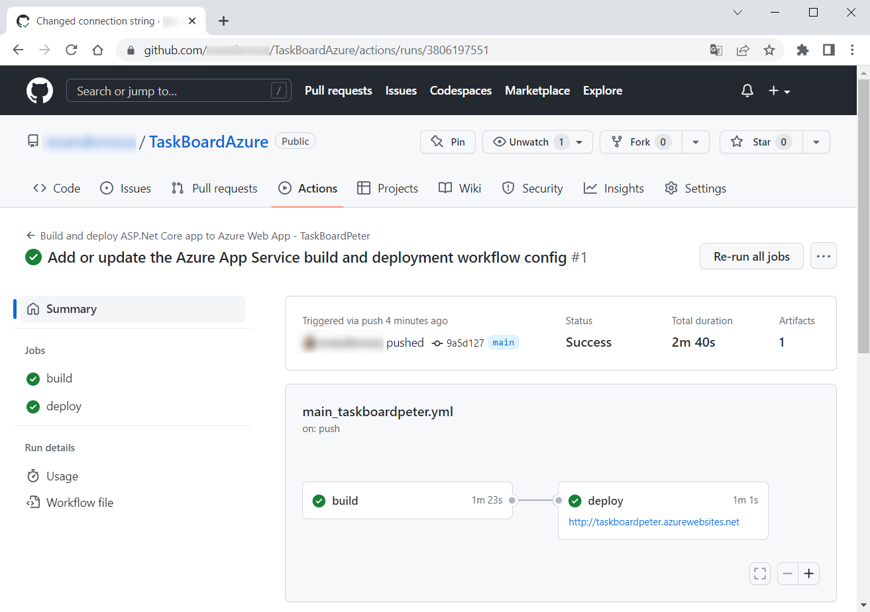

Step 5: Browse the App
Finally, you can access your app in Azure.
To get its URL address, go to the "App Service" page [Overview] and click the URL of your app:
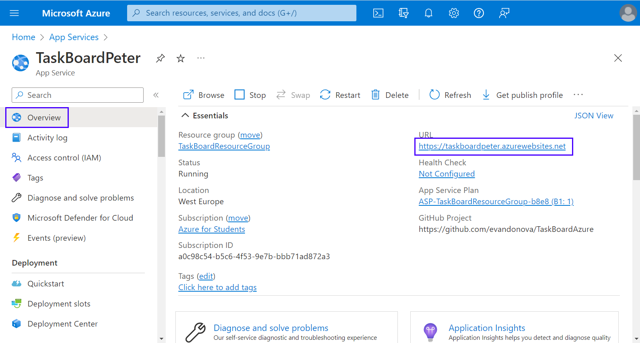
You can also navigate directly to https://<app-name>.azurewebsites.net. Your site should load and work:
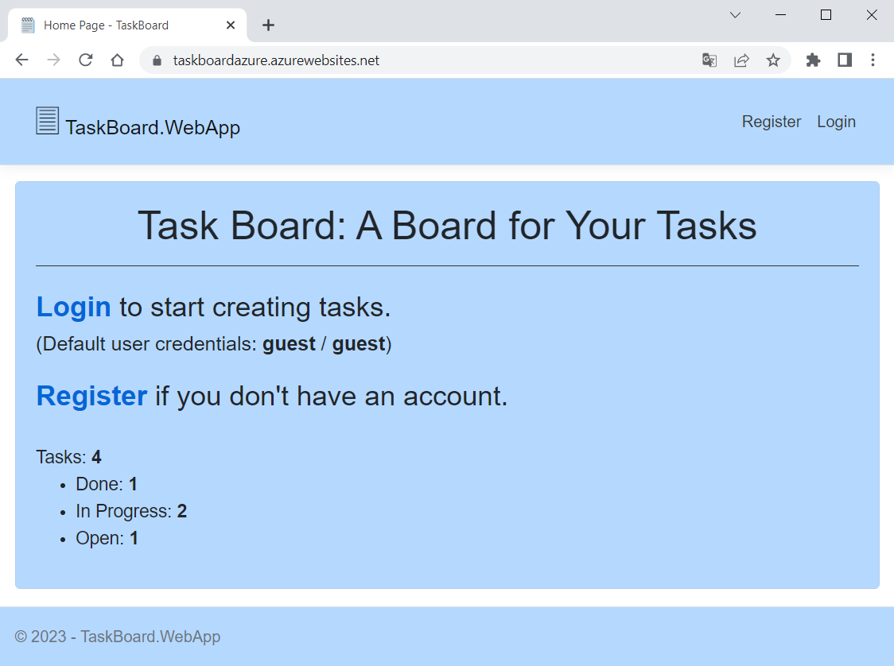
In addition, if you log in to Azure Portal and look at the resource groups you have, you will see that they are two – you have the "TaskBoardResourceGroup" and the "NetworkWatcherRG" groups:
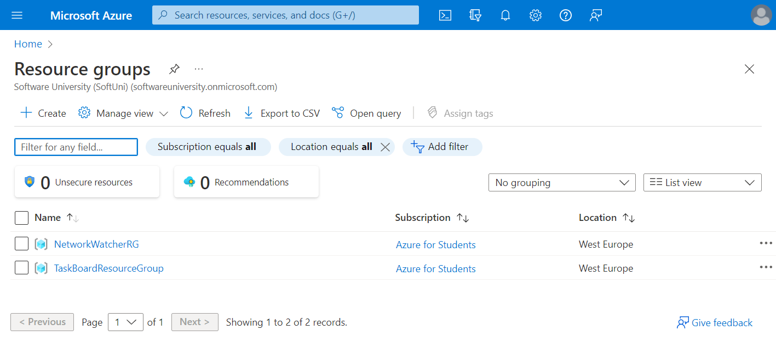
The "Network Watcher" resource represents an Azure region in the resource group and provides tools to monitor, diagnose, view metrics, and enable or disable logs for resources in an Azure virtual network.
You can delete it together with the "TaskBoardResourceGroup" when you don't need your Azure app anymore.
Note: in our case, we have the Database.EnsureCreated() method to create the database and apply migrations if any. If we don't have the Database.EnsureCreated() or Database.Migrate() method, we should either add them to the project's database context class or fulfill additional steps in Azure and GitHub to migrate the database: install EF Core and generate a database migration bundle in the workflow YAML file in GitHub and then generate database schema from a SSH terminal in Azure. You delete the migration method in your code, look online and try to do this, if you want.
Anyway, you now know how to deploy an ASP.NET Core app to Azure Web Apps from Azure Portal, using a GitHub Actions repo, too.

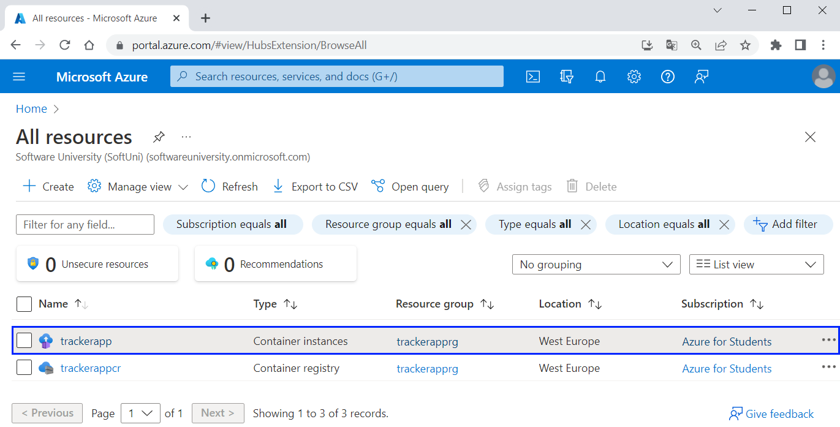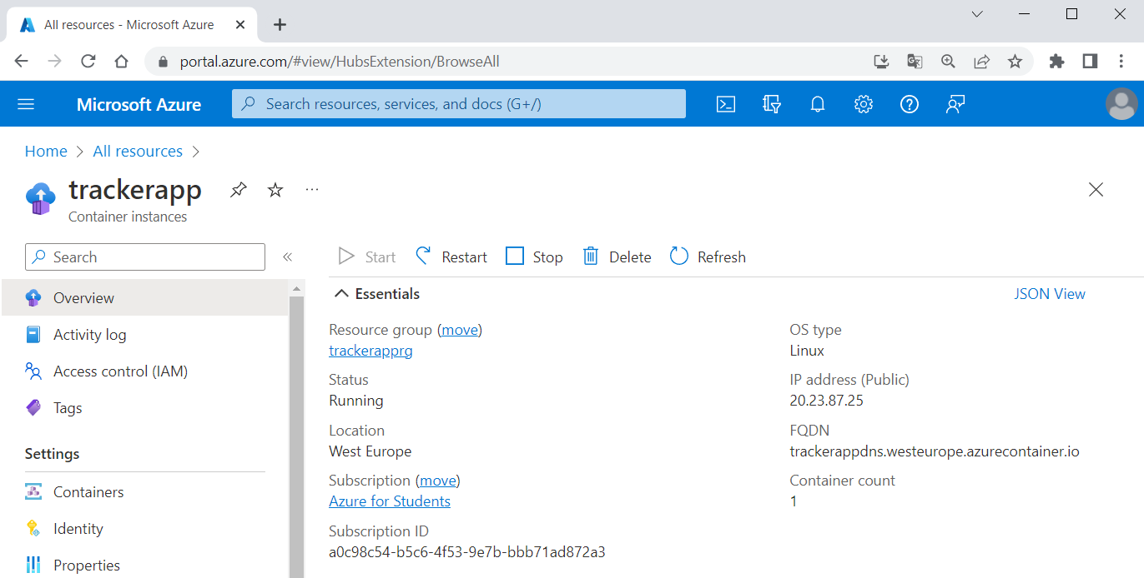
You can also view the log output of the container from Azure CLI:
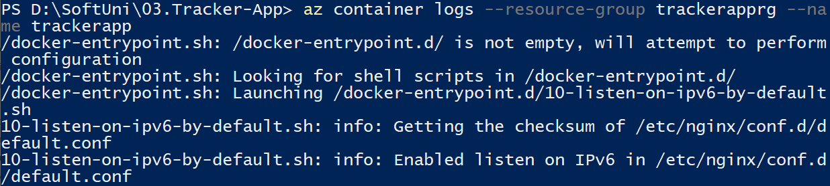
And finally, clear all resources by deleting the resource group with az group delete:
Now we know how to create resource groups, container registries, container instances, etc. and deploy a container app in Azure.

